Lab Manual

of

“EC 302: Wireless and

Mobile Communication ”

For B.Tech III

Year 2021 - 2022

Submitted By

**Harsh : U19EC046**

Division: A

Year: III

Dr. (Mrs.) Shweta N. Shah

Assistant Professor, ECED.



S V National Institute of Technology, Surat

Department of Electronics Engineering

Jan-May 2022

S V National Institute of Technology, Surat

Department of Electronics Engineering



**CERTIFICATE**

In context of practical work assigned, this is to certify that Mr. Harsh Suthar studying in B.Tech III year, DIV: A and bearing class Roll No U19EC046 has satisfactory completed the practical work offered in subject named“ Wireless and Mobile Communication” at Electronics Engineering Department, S V National Institute of Technology, Surat.

Date: 19-04-2022

Signature of Concerned Teacher

INDEX

|  |  |  |  |  |
| --- | --- | --- | --- | --- |
| Exp. No. | Title | Date | Grade | Sign |
| 1 | To Simulate M-PSK and M-QAM Modulation Techniques with the help of MATLAB software where M= 4, 8, 16, 32, 64. | 17/01/2022 |  |  |
| 2 | To study and observe the effect of multipath at different time instants. 1) To observe transmitted signal and received signal after multipath in time domain and frequency domain 2) To obtain the transfer function and impulse response of the time varying channel for various time instants. | 24/01/2022 |  |  |
| 3 | To Simulate M-PSK and M-QAM Modulation Techniques using AWGN channel considering input as an Image with the help of MATLAB software. Plot SNR v/s BER where M= 4. 8. 16. 32. 64 and constellation as well. | 31/01/2022 |  |  |
| 4 | To study and observe the effect of Doppler spread and delay spread for fast fading and slow fading channel and calculate the coherent bandwidth in MATLAB | 07/02/2022 |  |  |
| 5 | To study CDMA spreading/dispreading techniques and apply it on the Communication link in MATLAB. | 21/02/2022 |  |  |
| 6 | To Simulate Equalization Techniques using AWGN channel considering input as any random data as well as an Image with the help of MATLAB software. Also compare output of both with and without equalization. | 14/03/2022 |  |  |
| 7 | Calculation of received signal strength as a function of distance of separation, antenna height and carrier frequency. (To understand the path-loss prediction formula). | 21/03/2022 |  |  |
| 8 | To understand the cellular frequency reuse concept. Also Find: 1) The Co-Channel Cells for a Particular Cell 2) the Cell Clusters within certain Geographic Area | 21/03/2022 |  |  |
| 9 | To Perform QPSK and QAM modulation Techniques using ScienTech Trainer Kit. 9.1: To Perform QPSK modulation Technique 9.2: To Perform QAM modulation Technique | 28/03/2022 |  |  |
| 10 | Study of Direct Sequence Spread Spectrum (DSSS) Modulation and Demodulation Process. 1) Study of Spreading and Dispersing based on Spread Spectrum technique 2) Study of DSSS Modulation/Demodulation Using Analog Signal and Digital Signal as Inputs individually. | 04/04/2022 |  |  |
| 11 | To study about Software defined Radio platform. | 11/04/2022 |  |  |
| 12 | To study the 4G kit and explore the android platform. Also, develop the android application using 4G trainer kit. | 11/04/2022 |  |  |
| 13 | Lab Assignment (APK File) | 11/04/2022 |  |  |

**U19EC046 | WMC | LAB 1**

**AIM**

To Simulate M-PSK and M-QAM Modulation Techniques with the help of MATLAB software where M= 4, 8, 16, 32, 64. Also plot the constellation diagram for each M.

**THEORY**

## *Phase Shift Keying*

**Phase Shift Keying (PSK)** is the digital modulation technique in which the phase of the carrier signal is changed by varying the sine and cosine inputs at a particular time. PSK technique is widely used for wireless LANs, bio-metric, contactless operations, along with RFID and Bluetooth communications.

### *Binary Phase Shift Keying (BPSK)*

This is also called as **2-phase PSK** (or) **Phase Reversal Keying**. In this technique, the sine wave carrier takes two phase reversals such as 0° and 180°.

BPSK is basically a DSB-SC (Double Sideband Suppressed Carrier) modulation scheme, for message being the digital information.

***Quadrature Phase Shift Keying (QPSK)***

ASK, FSK and BPSK transmit one bit per symbol and hence carrier is assumed to have one of the two possible states to transmit 1 or 0.

Quadrature Phase Shift Keying (QPSK) is a form of Phase Shift Keying which transmits two bits per symbol.

Since it transmits two bits per symbol there are four possible combinations and thus there is four different phases.

* For 𝝿/4 QPSK, the four different phases are 45, 135, 225, 315.
* QPSK symbols are not represented by 0 or 1 but it is represented as 00, 01, 10 and 11.
* QPSK carry twice as much information as ordinary PSK using the same bandwidth.
* QPSK is used for satellite transmission of MPEG2 video, cable modems, videoconferencing, cellular phone systems, and other forms of digital communication over an RF carrier.

***Quadrature Amplitude Modulation (QAM)***

Quadrature Amplitude Modulation, QAM is a form of modulation that is a combination of phase modulation and amplitude modulation. The QAM scheme represents bits as points in a quadrant grid know as a constellation map. Constellation Map

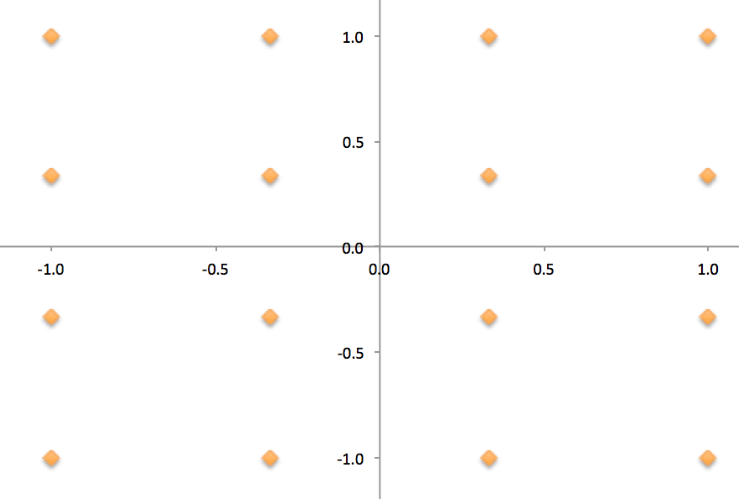

**Constellation map of 16-QAM**

***Phase Modulation***

* Represents bits by changing the angle of a wave.
* An example of Phase Modulation is QPSK-4.

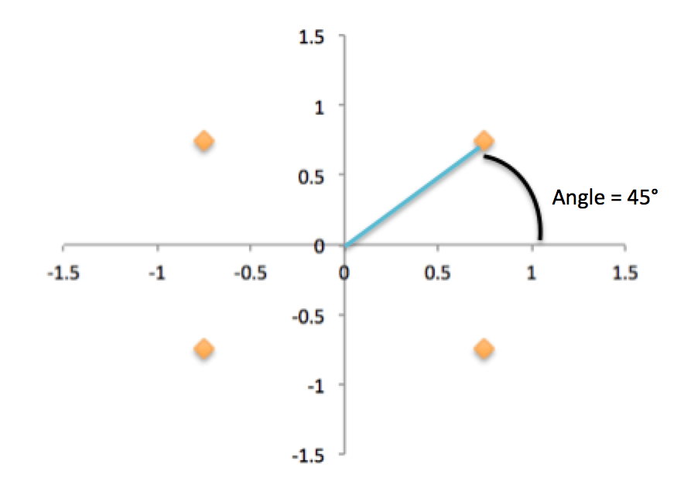

* As seen above, QPSK can have four different phase changes as four different angles.
* Is the angle of the constellation point.

## *QAM modulator*

The QAM modulator essentially follows the idea that can be seen from the basic QAM theory where there are two carrier signals with a phase shift of 90° between them. These are then amplitude modulated with the two data streams known as the I or In-phase and the Q or quadrature data streams. These are generated in the baseband processing area.

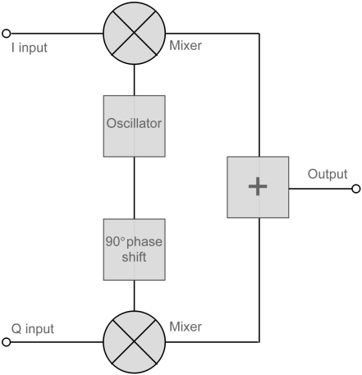

The two resultant signals are summed and then processed as required in the RF signal chain, typically converting them in frequency to the required final frequency and amplifying them as required.

## *QAM demodulator*

The QAM demodulator is very much the reverse of the QAM modulator.

The signals enter the system, they are split and each side is applied to a mixer. One half has the in-phase local oscillator applied and the other half has the quadrature oscillator signal applied.

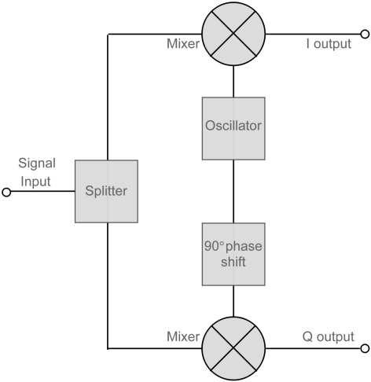

The basic modulator assumes that the two quadrature signals remain exactly in quadrature.

A further requirement is to derive a local oscillator signal for the demodulation that is exactly on the required frequency for the signal. Any frequency offset will be a change in the phase of the local oscillator signal with respect to the two double sideband suppressed carrier constituents of the overall signal.

Systems include circuitry for carrier recovery that often utilizes a phase locked loop - some even have an inner and outer loop. Recovering the phase of the carrier is important otherwise the bit error rate for the data will be compromised.

**ALGORITHM**

1. Read the image using imread and display the image
2. Convert the image matrix to column matrix
3. Convert the column matrix to binary column matrix
4. Modulate the obtained binary column matrix with qammod/pskmod along with order of modulation
5. Demodulate the received input using qamdemod/pskdemod
6. Reshape the demodulated matrix into matrix having 8 columns, after that convert this matrix to decimal using uint8 and bi2dec.
7. As the image is 256 x 256 reshape the output matrix to 256 x 256 and display the image.
8. Finally display the scatter plot.

**MATLAB CODE**

1. M PSK

|  |
| --- |
| clc;  clear all;  close all;  M = 128;  img = imread('cameraman.tif');  figure('name', 'transmitted')  imshow(img);  a = img(:);  b = de2bi(a);  c = double(b);  d = c(:);  y = pskmod(d,M);  e = pskdemod(y,M);  f = reshape(e,[65536,8]);  g = uint8(f);  h = bi2de(g);  x = reshape(h,256,256);  figure('name', 'received')  imshow(x);  scatterplot(y);  scatterplot(e); |

1. M QAM

|  |
| --- |
| clc;  clear all;  close all;  img = imread('cameraman.tif');  figure('name', 'transmitted')  imshow(img);  M = 64  a = img(:);  b = de2bi(a);  c = double(b);  d = c(:);  y = qammod(d,M);  e = qamdemod(y,M);  f = reshape(e,[65536,8]);  g = uint8(f);  h = bi2de(g);  x = reshape(h,256,256);  figure('name', 'received');  imshow(x);  scatterplot(y);  scatterplot(e); |

**OUTPUT**

1. M PSK

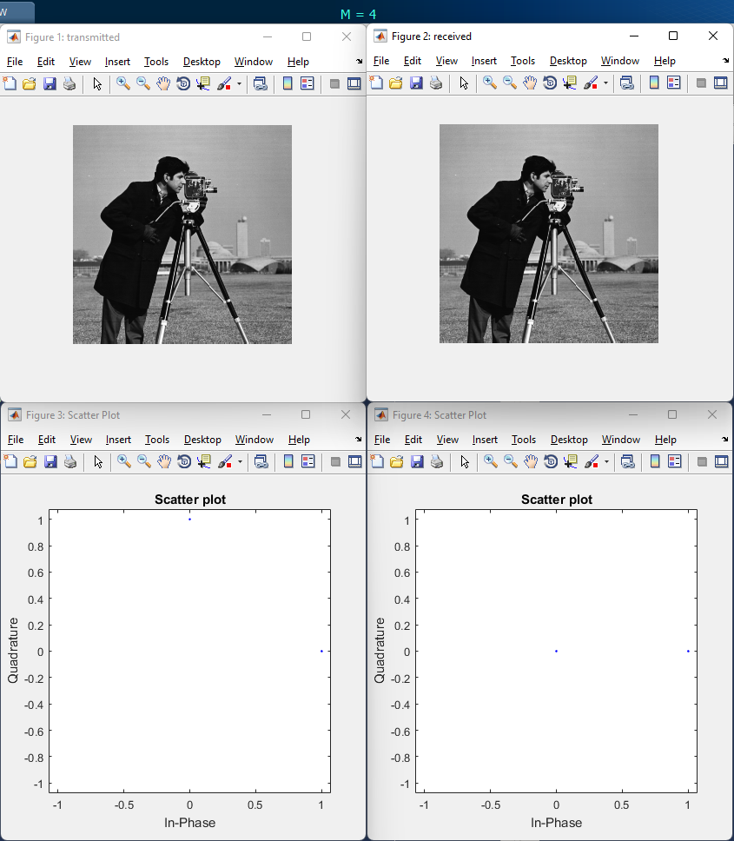

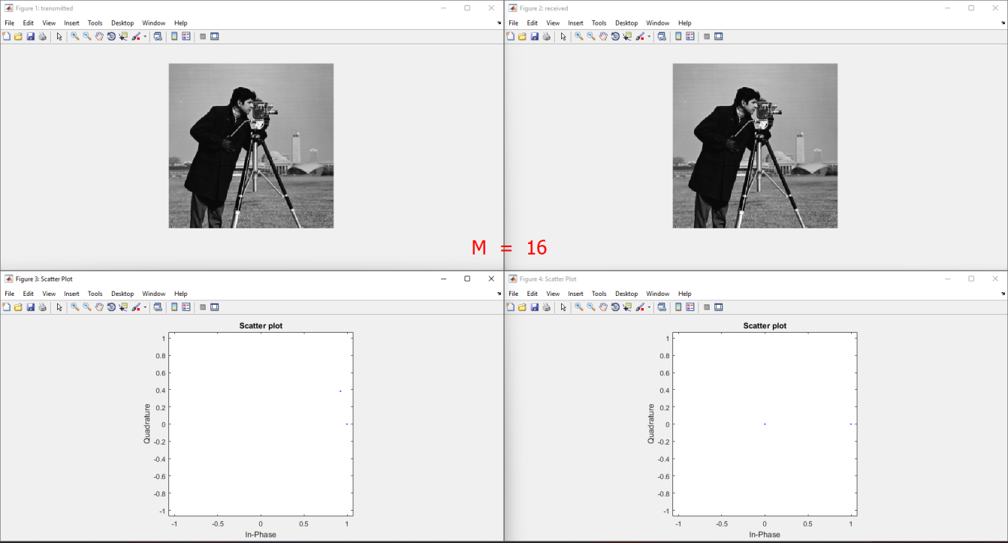

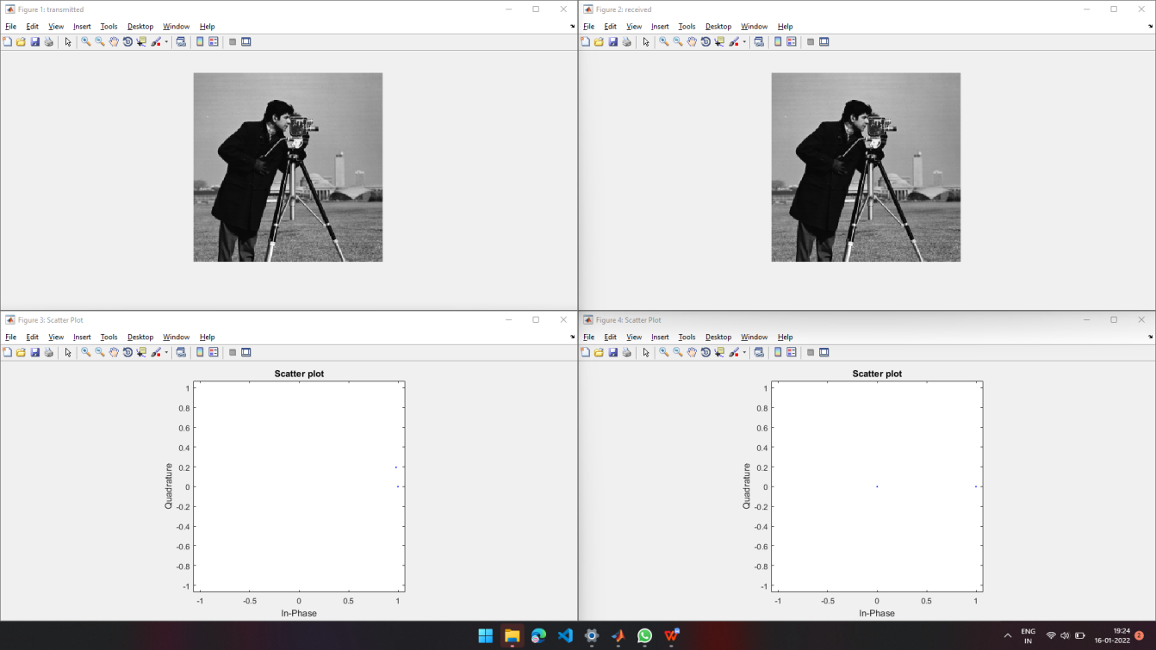

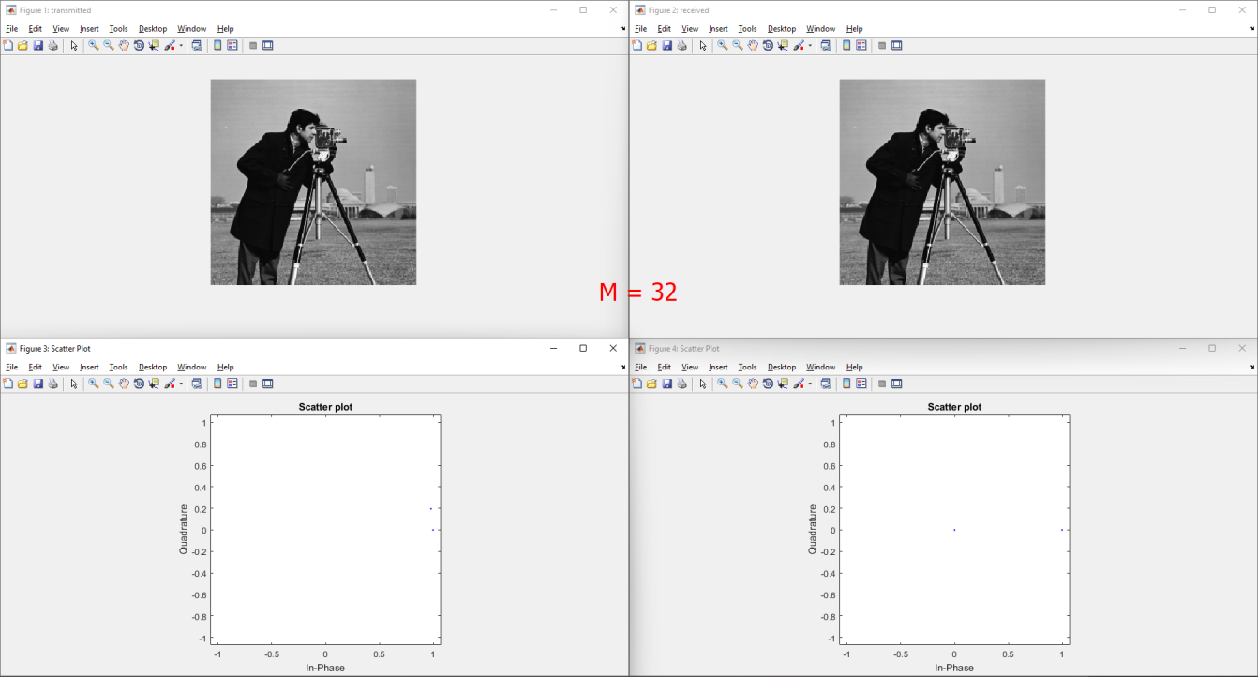

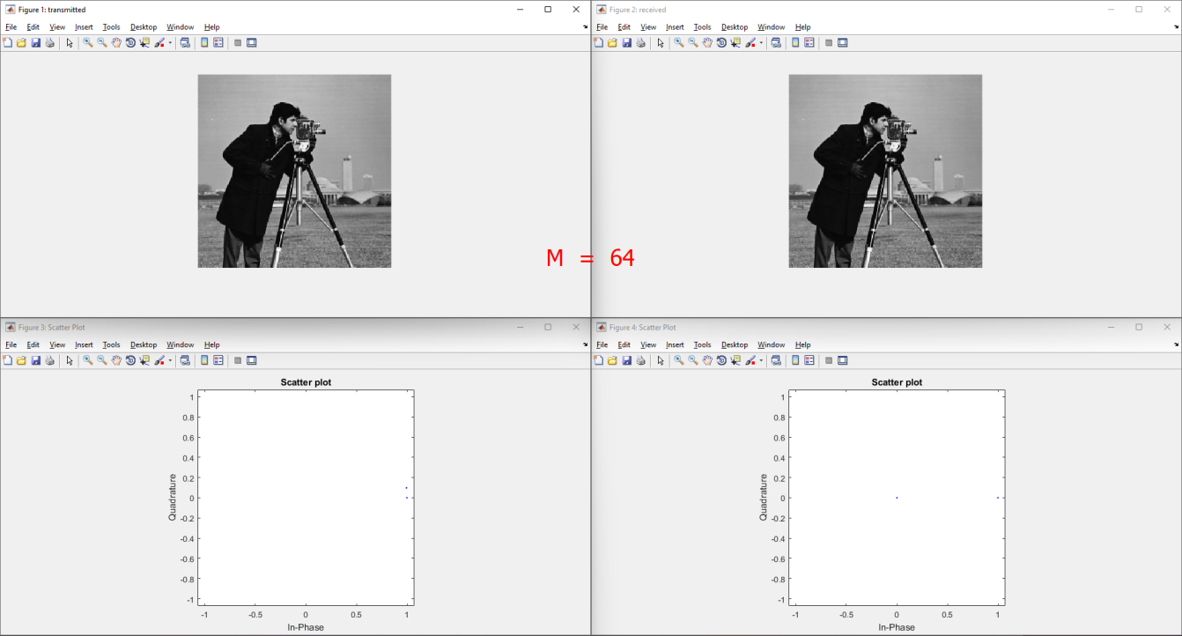

1. M QPSK

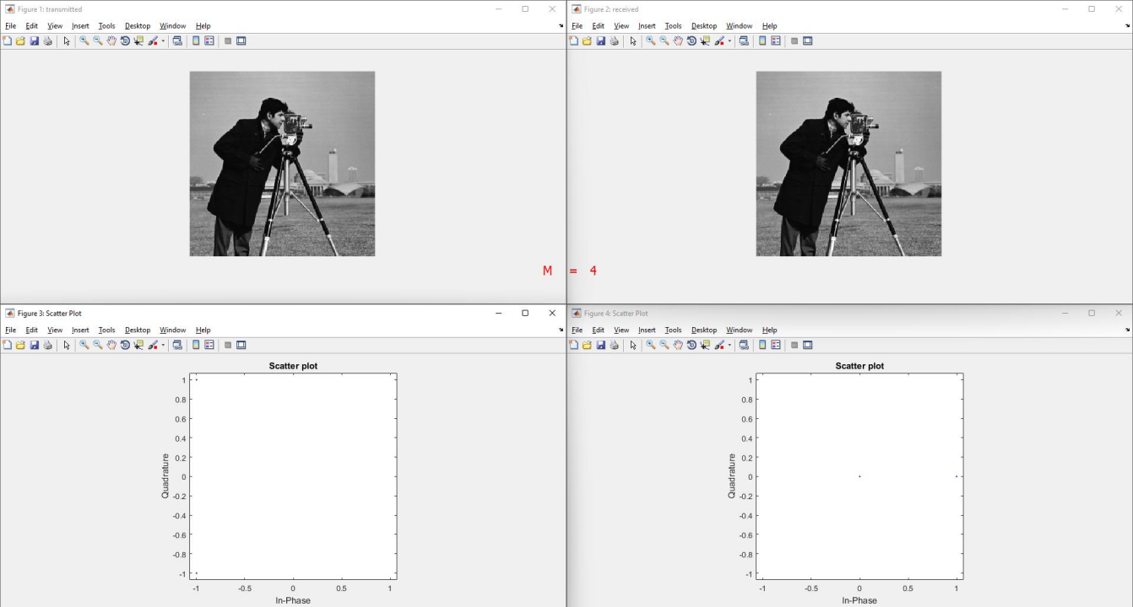

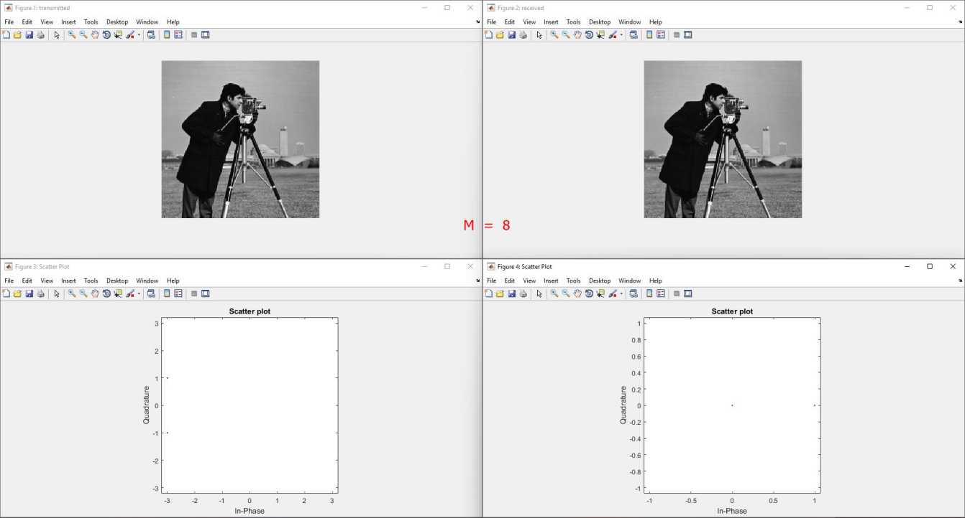

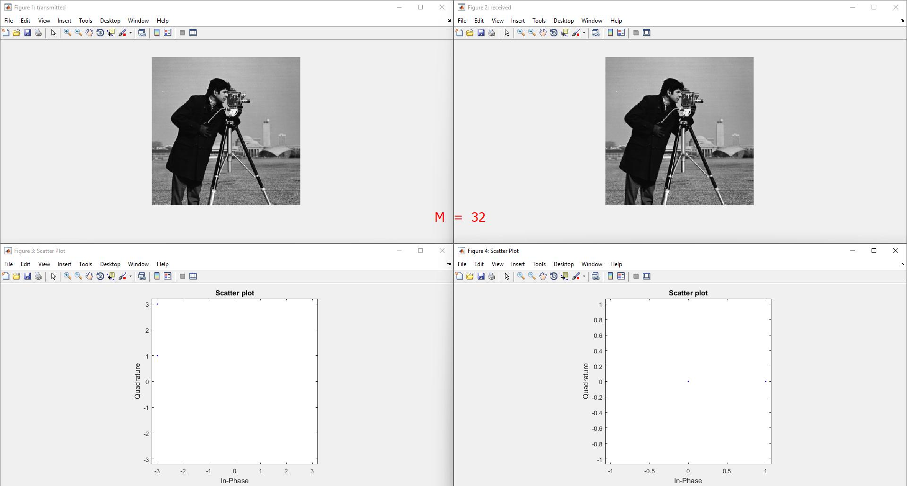



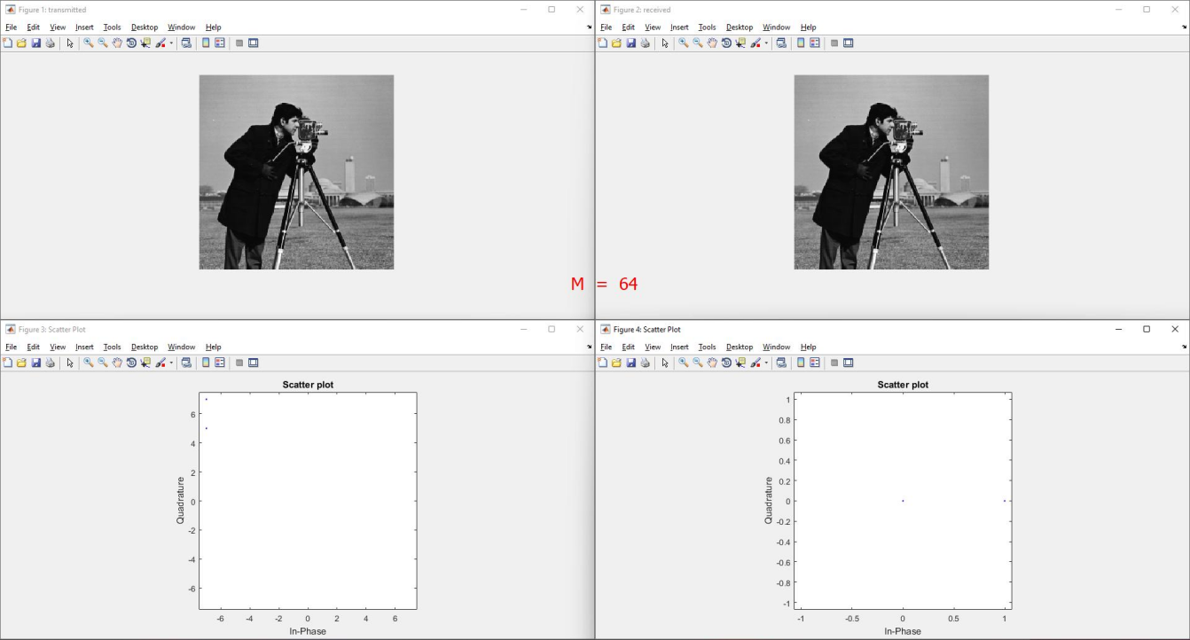

**CONCLUSION**

In this practical we have implemented M-PSK and M-QPSK for various values of M (4, 8, 16, 32 and 64). We have also modulated and demodulated a gray scaled image using MPSK and MQAM.

**U19EC046 | WMC | LAB 2**

**AIM**

To study and observe the effect of multipath at different time instants.

* To observe transmitted signal and received signal after multipath in time domain and frequency domain
* To obtain the transfer function and impulse response of the time varying channel for various time instants

**THEORY**

Consider the signal e(j*2*π*f0*t) transmitted from the transmitter and the corresponding received signal after subjected to multipath transmission is represented as follows:

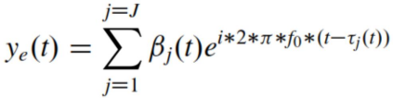

Where,

• J is the total no. of multipath,

• βj (t) is the attenuation in the jth path

• τj (t) is the time delay in the jth path

Attenuation and time delay of the jth path are functions of time. The function of the multipath channel at fo ,

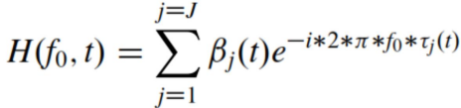

Similarly, it can be interpreted as the transfer function of the time varying for any value of f

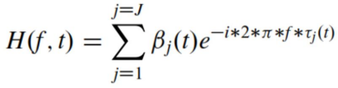

Thus the impulse response of the time-varying channel is obtained as follows

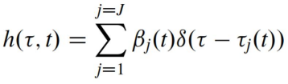

Here, the response of time varying multipath channel to the input signal is given by,

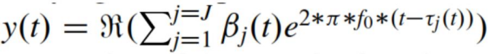

* Ideally, we expect channel transfer function envelop to be the flat response. But because of the presence of the Doppler spread, channel transfer function varies with time.
* We would like to have the rate at which channel transfer function is changing with time should be minimal.
* Thus the received signal is represented a

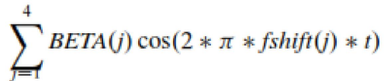

**MATLAB CODE**

|  |
| --- |
| **clc**  **clear all**    **f=5;**  **nop=2; % initial value of nop = 2**  **received_signal=[];**  **t=0:1/100:1; % choosing sampling freg=100Hz**  **transmitted_signal=cos(2*pi*f*t); % transmitted signal**  **z=1;**  **for t=0:1/100:1**  **temp=0;**  **for p=1:1:nop**  **beta(p)=rand/5; % for every delayed singal there will be 10**  **delay(p)=rand*t/5; % delay of each multipth component generated**  **temp=temp+beta(p)*exp(1i*2*pi*f*(t-delay(p)));**  **end**  **BETACOL{z}=beta;**  **DELAYCOL{z}=delay;**  **beta=0;**  **delay=0;**  **received_signal=[received_signal temp];**  **z=z+1;**  **end**    **save CONSTANTS BETACOL DELAYCOL**    **figure('name', 'U19EC046')**    **subplot(4,1,1)**    **plot(transmitted_signal)**    **title('U19EC046 Transmitted Signal');**    **subplot(4,1,2)**    **plot(real(received_signal))**    **title('U19EC046 received signal after multipath');**  **subplot(4,1,3)**    **plot(abs(fft(transmitted_signal)))**    **title('U19EC046 spectrum of the transmitted signal');**  **subplot(4,1,4)**    **plot(abs(fft(real(received_signal))))**    **title('U19EC046 spectrum of the received signal after multipath');**    **hold**    **load CONSTANTS**  **fs=100;**  **u=1;**  **for f=0:fs/101:(50*fs)/101**  **received_signal=[];**  **temp=0;**  **z=1;**  **for t=0:1/100:1**  **temp=0;**  **for p=1:1:nop**  **temp=temp+BETACOL{z}(p)*exp(1i*2*pi*f*(t-DELAYCOL{z}(p)));**  **end**  **received_signal=[received_signal temp];**  **z=z+1;**  **end**  **% The impulse response of the time-varying channel is computed as follows**  **t=0:1/100:1;**  **timevaryingTF_at_freq_f{u}=received_signal.*exp(-1i*2*pi*f*t);**  **u=u+1;**  **end**    **TEMP=cell2mat(timevaryingTF_at_freq_f');**  **for i=1:1:101**  **u=TEMP(:,i);**  **u1=[u;transpose(u(length(u):-1:2)')];**  **timevaringIR_at_time_t{i} = ifft(u1);**  **end**    **TFMATRIX=abs(cell2mat(timevaryingTF_at_freq_f'));**  **IRMATRIX=cell2mat(timevaringIR_at_time_t);**  **s=[2:2:8];**    **figure('name', 'U19EC046 Impulse Response');**  **for i=1:1:4**  **subplot (2,2,i)**  **plot(IRMATRIX(1:1:101,s(i)))**  **title(strcat('t=',num2str((s(i)-1)/100)))**  **end**    **figure('name', 'U19EC046 Transfer Function');**  **for j=1:1:4**  **subplot (2,2,j)**  **plot(real(ifft(IRMATRIX(1:1:101,s(j)))))**  **title(strcat('t=',num2str((s(j)-1)/100)))**  **end** |

**OUTPUT**

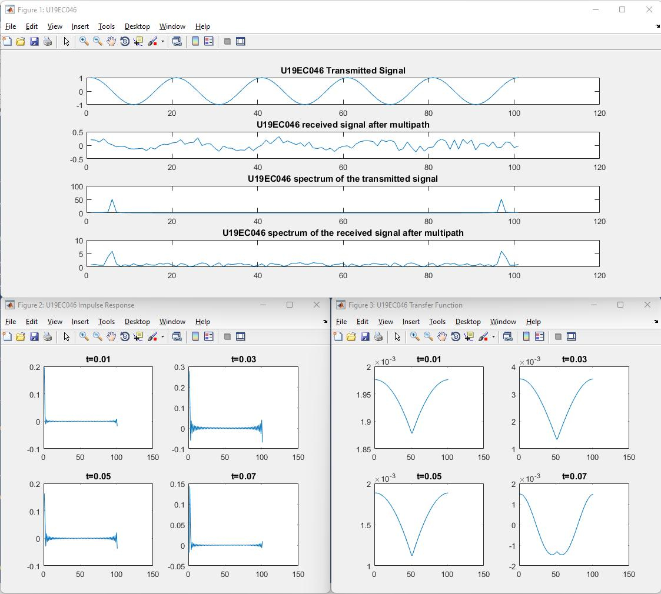

**CONCLUSION**

Hence, In this practical we have studied the effects of multipath signal transmission and also implemented the code for same in matlab. We have also plotted the transmitted and received signal in time and frequency domain and the channel impulse response as well as transfer function.

**U19EC046 | WMC | LAB 3**

**AIM**

To Simulate M-PSK and M-QAM Modulation Techniques using AWGN channel considering input as an Image with the help of MATLAB software. Plot SNR v/s BER where M= 4, 8, 16, 32, 64 and constellation as well.

**THEORY**

**AWGN**- A basic noise model used to mimic the effect of many random processes that occur in nature. Channel produces Additive White Gaussian Noise (AWGN)

**Additive**- The received signal equals the transmit signal plus some noise, where the noise is statistically independent of the signal.

r(t) = s(t)+w(t)

**White**- It refers that the noise has the same power distribution at every frequency or it has uniform power across the frequency band for the information system.

It is an analogy to the color white which has uniform emissions at all frequencies in the visible spectrum. if I focused a beam of light for each color on the visible spectrum onto a single spot, that combination would result in a beam of white light. As a consequence, the Power Spectral Density (PSD) of white noise is constant for all frequencies ranging from −∞ to +∞, as shown in figure below.

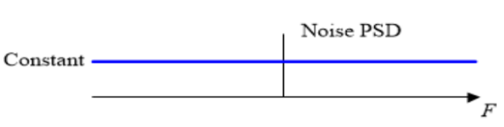

**Gaussian**- Gaussian distribution, or a normal distribution, has an average of zero in the time domain, and is represented as a bell-shaped curve. The probability distribution of the noise samples is Gaussian with a zero mean. The values close to zero have a higher chance of occurrence while the values far away from zero are less likely to appear.

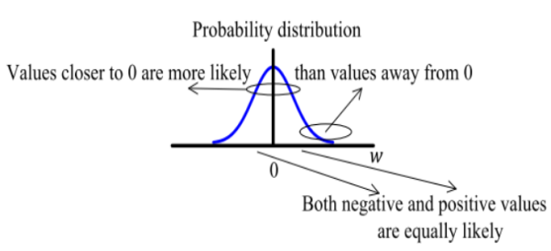

In reality, the ideal flat spectrum from −∞ to +∞ is true for frequencies of interest in wireless communications (a few kHz to hundreds of GHz) but not for higher frequencies.

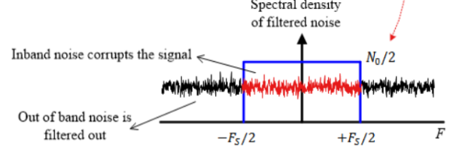

**Signal to Noise Ratio:**

The SNR or S/N is a measure used in science and engineering that compares the level of a desired signal to the level of background noise. It is defined as the ratio of signal power to the noise power, often expressed in decibels. A ratio higher than 1:1 (greater than 0 dB) indicates more signal than noise. SNR, bandwidth, and channel capacity of a communication channel are connected by the Shannon –Hartley theorem.

SNRdB = 10 log10 (Psignal/Pnoise)

**Shannon-Hartley theorem:**

It states the channel capacity (bits per second) OR information rate of data that can be communicated at low error rate using an average received signal power through communication channel subject to additive white Gaussian noise (AWGN) of power.

C = B log2(1+S/N)

Where, B is the Bandwidth of the channel in hertz.

5dB – 10dB : is below the minimum level to establish a connection, due to the noise level being nearly indistinguishable from the desired signal.

25dB – 40dB : is deemed to be good.

4dB or higher : is considered to be excellent.

**Algorithm:**

**MATLAB CODE**

|  |
| --- |
| clc  clear all;  close all;    % read the image  img=imread('cameraman.tif');    maxM = 6; % maximum symbol rate  maxSNR = 40; % maximum SNR value    % initializing an matrix to store BER for different symbol rates  BERQAM = zeros(maxM,maxSNR/2);  BERPSK = zeros(maxM,maxSNR/2);    QAMstr = 'QAM (M = %d)';  PSKstr = 'PSK (M = %d)';    % SNR ranges  t = 1:2:maxSNR;      figure(1);  subplot(maxM/3,3,1);  imshow(img);  title('Original');    figure(2);  subplot(maxM/3,3,1);  imshow(img);  title('Original');    % for loop to calculate stuff on different symbol rates  for m = 2:maxM    % modulation order  ModOrd = 2^m;  symbolSize = log2(ModOrd);    % we need to pad zeros, why?  % suppose image size is 256*256 and each elment represents rgb value from  % 0 to 255, i.e. 8 bits. Consider symbol rate 3, we need to represent image  % in array of 3 bits. if 256*256 is not divisible by 3 then we cannot  % reshape it into array of 3 bits. hence we need to pad the image matriz  % so that number of elements in image size is divisible by symbol rate.    AddZero = rem(length(img),symbolSize);    if AddZero ~= 0  img = [img; zeros(symbolSize - AddZero, numel(img)/length (img))];  end    % stuff meant to reshape the image matrix to array of m bits  binaryImage = de2bi(img);  reshapedImage = reshape(binaryImage, 8*length(binaryImage)/symbolSize, symbolSize);  img_dec = bi2de(reshapedImage);    % finnaly modulate  yQAM = qammod(img_dec, ModOrd);  yPSK = pskmod(double(img_dec), ModOrd);    % for each SNR value populate BER values  for s = 1:2:maxSNR  nQAM = awgn(yQAM,s);  nPSK = awgn(yPSK,s);  zQAM = qamdemod(nQAM, ModOrd);  zPSK = pskdemod(nPSK, ModOrd);  [a,b] = biterr(img_dec,zQAM);  % (s+1)/2 because SNR jumps 2 value each time  % and BER matrix has size [m, maxSNR]  BERQAM(m,(s+1)/2) = 100*b;  [c,d] = biterr(img_dec,zPSK);  BERPSK(m,(s+1)/2) = 100*d;  end    % get the image matrix from demod, exatly opposite during modulation  QAM_dec = de2bi(zQAM);  QAM_rsp = reshape(QAM_dec, size(binaryImage));  QAMM = bi2de(QAM_rsp);  QAMM = uint8(reshape(QAMM,size(img)));    PSK_dec = uint8(de2bi(zPSK));  PSK_rsp = reshape(PSK_dec, size(binaryImage));  PSKK = bi2de(PSK_rsp);  PSKK = uint8(reshape(PSKK,size(img)));    % plot the scatter plot  scatterplot(nQAM);  scatterplot(nPSK);    figure(1);  subplot(maxM/3,3,m);  imshow(QAMM);  title(sprintf(QAMstr,ModOrd));    figure(2);  subplot(maxM/3,3,m);  imshow(PSKK);  title(sprintf(PSKstr,ModOrd));    figure(maxM+1);    subplot(211);  plot(t,BERQAM(m,:),'linewidth',2,'DisplayName',sprintf(QAMstr,ModOrd));  title('BER vs SNR (QAM) U19EC046');  xlabel('Signal to Noise Ratio');  ylabel('Bit Error Rate(%)');  legend;  hold on;    subplot(212);  plot(t,BERPSK(m,:),'linewidth',2,'DisplayName',sprintf(PSKstr,ModOrd));  title('BER vs SNR (PSK) U19EC046');  xlabel('Signal to Noise Ratio');  ylabel('Bit Error Rate(%)');  legend;  hold on;    end |

**OUTPUT**

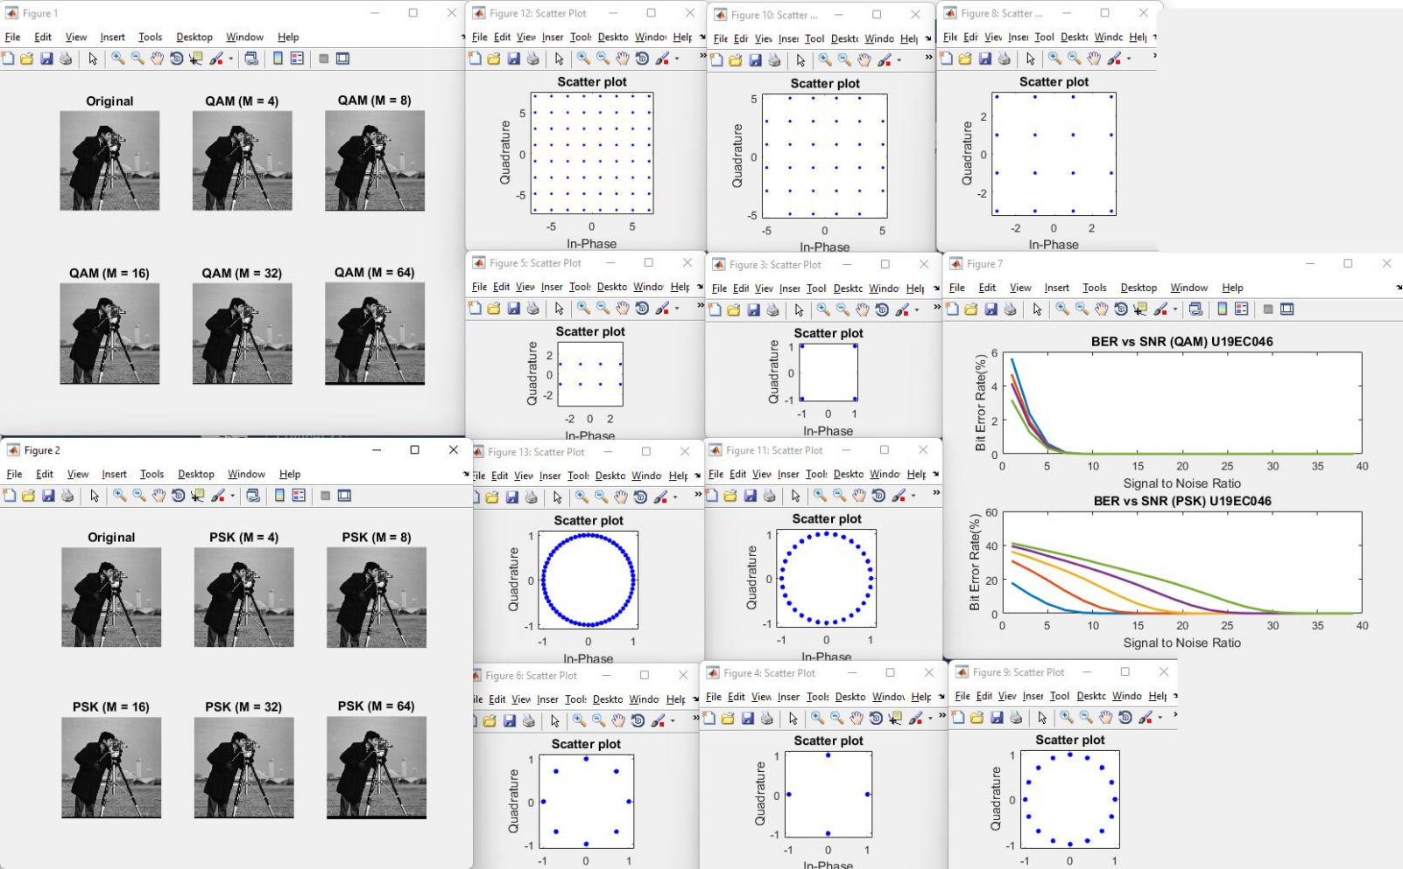

**CONCLUSION**

In this experiment we have successfully transmitted the input source image using different orders of PSK modulation technique and calculated the Bit Error Rates for different SNR values for each of them. It was observed that the BER in QAM reduces quickly as SNR increases as compared to PSK. Image quality decreases sligthly as modulation order increases.

**U19EC046 | WMC | LAB 4**

**AIM**

To study and observe the effect of doppler spread and delay spread for fast fading and slow fading channel and calculate the coherent bandwidth in MATLAB.

**THEORY**

As we know that radio frequency signal takes different path to reach the destination due to multiple paths. These multiple paths cause reflection, refraction and scattering of radio signal. Hence when the signal is transmitted from one place to the other, multiple copies of the signal is received with different amplitudes and different delays (leads to different time of arrival) at the receiver.

For example, if an impulse is transmitted then it will be no longer an impulse when it is received at the other end, but it will become a pulse with spreading effect. The effect which makes this spreading of signal is known as Delay spread.​ To measure performance of a wireless system different scenarios from low to medium to high delay spreads are considered for test purpose. Delay spread helps determine coherence bandwidth and coherence time of a wireless system. ​

Coherence time = (1/Doppler spread)​

In doppler spread, how fast the transfer function of the time-varying channel changes with time for a fixed frequency is to be studied. Doppler spread and the coherence time are used for the same. In delay spread, how fast the transfer function of the time-varying channel changes with frequency at a particular time instant is to be studied.​

**Doppler Spread:**

Doppler shift is the random changes in a channel introduced as a result of a mobile user’s mobility. Doppler spread has the effect of shifting or spreading the frequency components of a signal. Types of fading on the basis of doppler spread are fast fading and slow fading. ​

* Fast fading: Channel impulse response changes rapidly within the symbol duration. ​
* Slow fading: Channel impulse response changes at a rate much slower than the transmitted symbol bandwidth. ​
* Doppler spread is expressed in the following formula. As mentioned, doppler spread is defined as maximum doppler shift (fm). ​

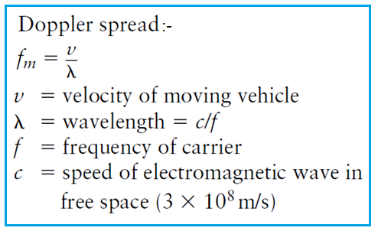

**Coherence Time:**

The coherence time is the time over which a propagating wave may be considered coherent. In other words, it is the time interval within which its phase is, on average, predictable.​

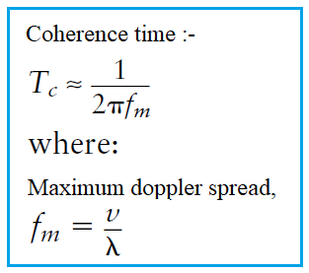

**Algorithm:**

* For fast fading doppler spread, Consider the signal cos 2𝜋𝑓𝑜𝑡 𝑓𝑜 = 1 MHz. Also let the rate at which the delay (𝜏𝑗) is changing with time be randomly chosen as TAU_J = [0.62 1.84 0.86 0.37] for fast fading.
* Hence the corresponding Doppler shift for the frequency 𝑓𝑜 in the corresponding paths is obtained as DJ = −𝑓𝑜*TAUJ and the actual shift in the frequency is given as fshift = |DJ + 𝑓𝑜| = [0.38 0.84 0.14 0.63]
* Attenuation in individual paths, BETA = [0.23 0.17 0.23 0.44]
* Thus the received signal is represented as $\sum_{j=1}^{4}{BETA}$ (𝑗)cos(2 ∗ 𝜋 ∗ 𝑓𝑠ℎ𝑖𝑓𝑡 𝑗 ∗ 𝑡)
* Plot the received signal and the corresponding spectrum.
* For slow fading doppler spread, take Tau as [0.0042 0.0098 0.0030 0.007] and Beta as [0.2691 0.4228 0.5479 0.9427];

**MATLAB CODE**

|  |
| --- |
| ***%% fast fading***  **clc;**  **clear all;**  **close all;**    **Tau0 =0;**  **f=1;**  **nop =4;**  **Tauj = [0.62 1.84 0.86 0.37];**  **BETA = [0.23 0.17 0.23 0.44];**  **fshift=[];**  **for j=1:1:nop**  **fshift(j)=abs(-f+Tauj(j));**  **end**  **rxsignal =[];**  **tvtf = [];**  **t = 0:(1/100):100;**  **txsignal = cos(2*pi*f*t);**  **for t =0:(1/100):100**  **rx =0;**  **tf =0;**  **for p=1:1:nop**  **rx = rx+ BETA(p)*cos(2*pi*fshift(p)*t);**  **tf = tf+BETA(p)*exp(-1i*2*pi*f*Tau0)*exp(-1i*2*pi*f*Tauj(p)*t);**  **end**  **rxsignal = [rxsignal rx];**  **tvtf = [tvtf tf];**  **end**    **figure(1)**  **subplot(2,2,1)**  **plot(txsignal)**  **axis([1 1000 -2 2]);**  **title('Transmitted signal U19EC046');**  **xlabel('Samples in time domain with Ts = 1/100 micro secs');**  **ylabel('amplitude');**    **subplot(2,2,2)**  **fre = (0:1:length(rxsignal)-1)/100;**  **plot(real(rxsignal),'r')**  **axis([1 1000 -2 2]);**  **title('Received signal U19EC046');**  **xlabel('Samples in time domain with Ts = 1/100 micro secs');**  **ylabel('amplitude');**    **subplot(2,2,3)**  **plot(fre, abs(fft(txsignal)));**  **axis([0 2 0 1000]);**  **title('Spectrum of transfer signal U19EC046');**  **xlabel('Frequency in MHz');**  **ylabel('amplitude');**    **subplot(2,2,4)**  **plot(fre, abs(fft(real(rxsignal))));**  **axis([0 2 0 1000]);**  **title('Corresponding spectrum of received signal U19EC046');**  **xlabel('Frequency in MHz');**  **ylabel('amplitude');**    **figure(2)**  **subplot(2,1,1)**  **plot(abs(tvtf));**  **axis([0 1000 0 2]);**  **title('Time varying transfer function value magnitude U19EC046');**  **xlabel('Samples in time domain with Ts = 1/100 micro secs');**  **ylabel('amplitude');**    **subplot(2,1,2)**  **plot(phase(tvtf));**  **axis([0 1000 -25 0]);**  **title('Time varying transfer function value phase U19EC046');**  **xlabel('Samples in time domain with Ts = 1/100 micro secs');**  **ylabel('angle');** |

|  |
| --- |
| ***%% slow fading***  **clc;**  **clear all;**  **close all;**    **Tau0 =0;**  **f=1;**  **nop =4;**    **Tauj = [0.0042 0.0098 0.0030 0.007];**  **BETA = [0.2691 0.4228 0.5479 0.9427];**  **fshift=[];**  **for j=1:1:nop**  **fshift(j)=abs(-f+Tauj(j));**  **end**  **rxsignal =[];**  **tvtf = [];**  **t = 0:(1/100):100;**  **txsignal = cos(2*pi*f*t);**  **for t =0:(1/100):100**  **temp =0;**  **temp1 =0;**  **for p=1:1:nop**  **temp = temp+ BETA(p)*cos(2*pi*fshift(p)*t);**  **temp1 = temp1+BETA(p)*exp(-1i*2*pi*f*Tau0)*exp(-1i*2*pi*f*Tauj(p)*t);**  **end**  **rxsignal = [rxsignal temp];**  **tvtf = [tvtf temp1];**  **end**    **figure(1)**  **subplot(2,2,1)**  **plot(txsignal)**  **axis([1 10000 -2 2]);**  **title('Transmitted signal U19EC046');**  **xlabel('Samples in time domain with Ts = 1/100 micro secs');**  **ylabel('amplitude');**    **subplot(2,2,2)**  **fre = (0:1:length(rxsignal)-1)/100;**  **plot(real(rxsignal),'r')**  **axis([1 10000 -2 2]);**  **title('Real part of received signal U19EC046');**  **xlabel('Samples in time domain with Ts = 1/100 micro secs');**  **ylabel('amplitude');**    **subplot(2,2,3)**  **plot(fre, abs(fft(txsignal)));**  **axis([0 2 0 1000]);**  **title('Spectrum of transfer signal U19EC046');**  **xlabel('Frequency in MHz');**  **ylabel('amplitude');**    **subplot(2,2,4)**  **plot(fre, abs(fft(real(rxsignal))));**  **axis([0 2 0 1000]);**  **title('Real part of corresponding spectrum of received signal U19EC046');**  **xlabel('Frequency in MHz');**  **ylabel('amplitude');**    **figure(2)**  **subplot(2,1,1)**  **plot(abs(tvtf));**  **axis([0 10000 0 2.3]);**  **title('Time varying transfer function value magnitude U19EC046');**  **xlabel('Samples in time domain with Ts = 1/100 micro secs');**  **ylabel('amplitude');**    **subplot(2,1,2)**  **plot(phase(tvtf));**  **axis([0 10000 -4 0]);**  **title('Time varying transfer function value phase U19EC046');**  **xlabel('Samples in time domain with Ts = 1/100 micro secs');**  **ylabel('angle');** |

|  |
| --- |
| ***%% delay spread***  **clc;**  **clear all;**  **close all;**    **TAU0=0;**  **t0=1;**  **nop=4;**  **BETA=rand(1,nop);**  **TAUJ=(rand(1,nop)*2-1);**  **rxsignal=[];**  **BETA= [0.9575 0.9649 0.1576 0.9706];**  **TAUJ= [0.9143 -0.0292 0.6006 -0.7162];**  **tv_tf_comp_at_t0=[];**  **z=1;**  **t1=1;**    **for f=0:(1/1000):0.999**  **temp=0;**  **temp1=0;**  **for p=1:1:nop**  **temp1=temp1+BETA(p)*exp(-1i*2*pi*f*TAU0)*exp(-1i*2*pi*f*TAUJ(p)*t0);**  **end**  **tv_tf_comp_at_t0=[tv_tf_comp_at_t0 temp1];**  **end**    **figure;**  **plot((0:(1/1000):0.999)*1000,abs(tv_tf_comp_at_t0));**  **title('Time Varying Transfer Function computed at the time instant t0=1us U19EC046')**  **xlabel('Frequency in Khz');**  **ylabel('Amplitude');** |

**OUTPUT**

1. Fast Fading

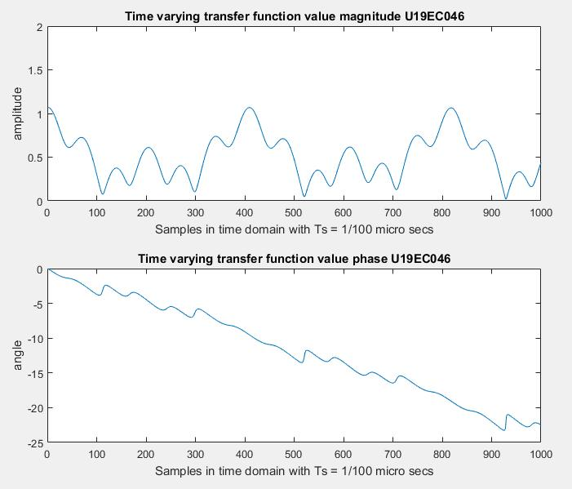

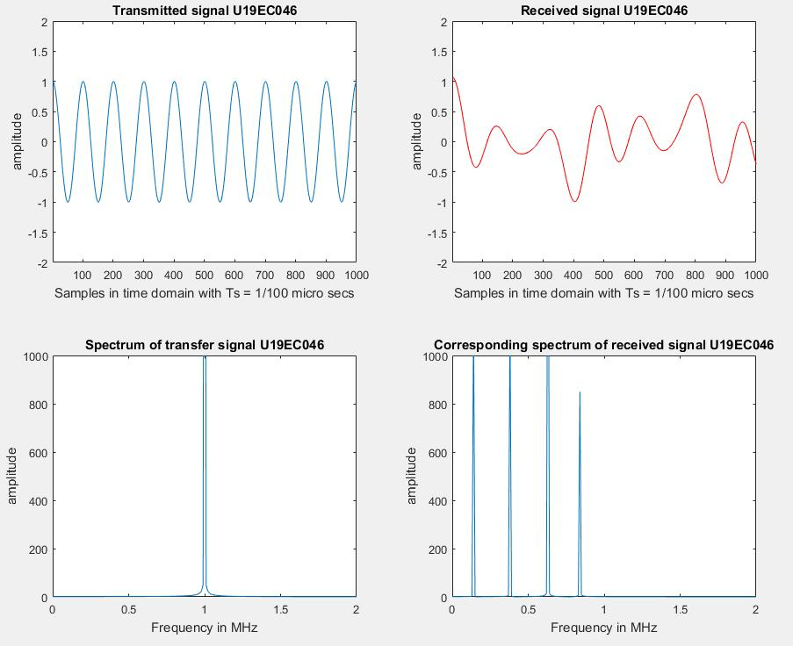

1. Slow Fading

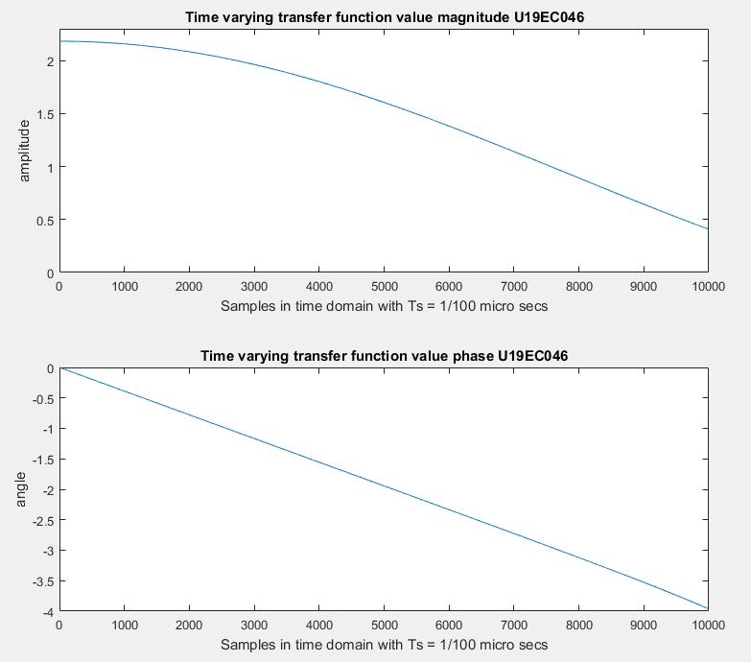

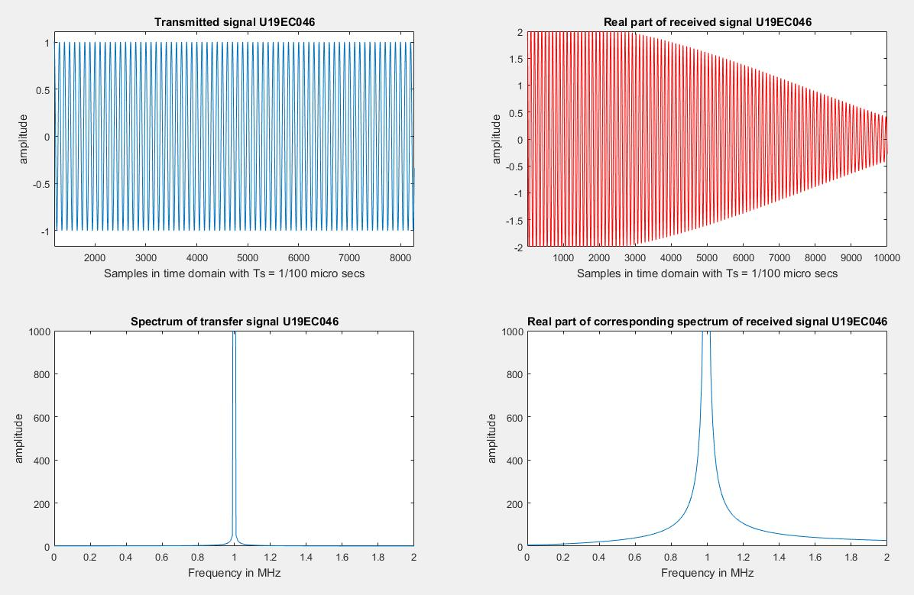

1. Delay Spread

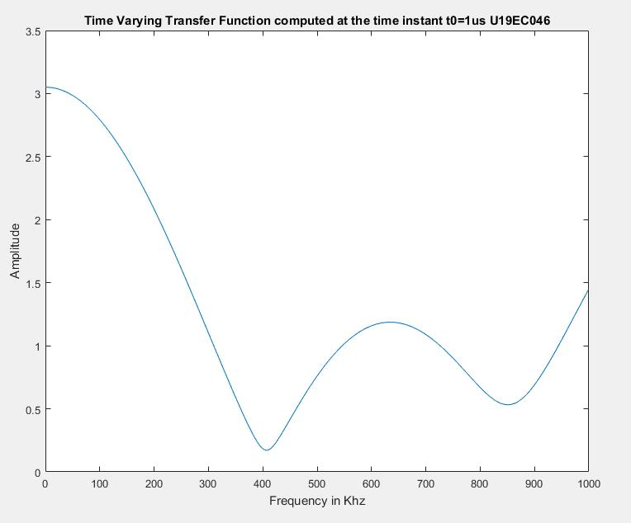

**Calculation:**

Coherence Time = 1/2D = 73us

Delay Spread L = 1.6306

Coherence Frequency = 1/2L = 306KHz

**CONCLUSION**

In doppler spread, we studied that how fast the transfer function of the time varying channel changes with time for a fixed frequency. Doppler spread and the coherence time are used for the same. In delay spread, how fast the transfer function of the time-varying channel changes with frequency at a particular time instant.

**U19EC046 | WMC | LAB 5**

**AIM**

To study CDMA spreading/dispreading techniques and apply it on the Communication link in MATLAB

**THEORY**

Multiple Access Techniques:

Multiple access techniques are used to allow a large number of mobile users to share the allocated spectrum in the most efficient manner.

* As the spectrum is limited, so the sharing is required to increase the capacity of the cell or over a geographical area by allowing the available bandwidth to be used at the time by different users
* And this must be done in a way such that the quality of the service doesn’t degrade within the existing users
* A cellular system divides any given area into cells where a mobile unit in each cell communicates with a base station.
* The main aim in the cellular system design is to be able to increase the capacity of the channel i.e., to handle as many as calls as possible in a given bandwidth with a sufficient level of quality of service.

These includes mainly the following:

1. Frequency division multiple-access(FDMA)
2. Time division multiple-access(TDMA)
3. Code division multiple-access(CDMA)

**FDMA:**



* Each individual user is assigned a pair of frequencies while making or receiving a call as shown in Figure.
* One frequency is used for downlink and one pair for uplink. This is called frequency division duplexing (FDD).

**TDMA:**



* In digital systems, continuous transmission is not required because users do not use the allotted bandwidth all the time. In such cases, TDMA is a complimentary access technique to FDMA.
* Global Systems for Mobile communications (GSM) uses the TDMA technique.
* In TDMA, the entire bandwidth is available to the user but only for a finite period of time. The users are allotted time slots during which they have the entire channel bandwidth at their disposal, as shown in Figure.

**CDMA:**



* In CDMA, the same bandwidth is occupied by all the users, however they are all assigned separate codes, which differentiates them from each other shown in Figure .
* CDMA utilize a spread spectrum technique in which a spreading signal (which is uncorrelated to the signal and has a large bandwidth) is used to spread the narrow band message signal.

**MATLAB CODE**

1. Part I

|  |
| --- |
| **clc**  **clear all**  **data = randi([0 1], 1046, 1);**  **[n m] = size(data);**  **expanded_data = repmat(data, [1, 8]);**  **H = commsrc.pn(...**  **'GenPoly', [3 2 0], ...**  **'InitialStates', [0 0 1], ...**  **'CurrentStates', [0 0 1], ...**  **'Mask', [0 0 1], ...**  **'NumBitsOut', 8);**  **pn=generate(H);**  **pn_repeated = repmat(pn', [n 1]);**  **xored = xor(expanded_data, pn_repeated);**  **M=2;**  **data_vector = reshape(xored, [numel(xored)/M M]);**  **decimal_data_vector = bi2de(data_vector);**  **transmitted = pskmod(decimal_data_vector, 2^M);**  **SNR = -10:10;**  **BER = zeros(length(SNR), 1);**  **for i = 1:length(SNR)**  **received = awgn(transmitted, SNR(i));**  **demodulated = pskdemod(received, 2^M);**  **binary_data_vector = de2bi(demodulated);**  **binary_data = reshape(binary_data_vector, size(expanded_data));**  **despread_data = xor(binary_data, pn_repeated);**  **msg_rx = round(mean(despread_data, 2));**  **BER(i) = mean(abs(msg_rx - data));**  **end**  **plot(SNR,smooth(BER, 0.5));**  **title('BER vs SNR');**  **xlabel('SNR');**  **ylabel('BER');** |

1. Part II

|  |
| --- |
| **clc;**  **clear all;**  **close all;**  **for k=1:3**  **ber = [];**  **input_signal = randi([0,1],1000,1);**  ***%PN sequence***  **if k==1**  **H = commsrc.pn('Genpoly',[3 2 0],'InitialStates',[0 0 1],'CurrentStates',[0 0 1],'Mask',[0 0 1],'NumBitsOut',8);**  **pn = generate(H);**  **elseif k==2**  **H = commsrc.pn('Genpoly',[4 3 0],'InitialStates',[0 0 0 1],'CurrentStates',[0 0 0 1],'Mask',[0 0 0 1],'NumBitsOut',8);**  **pn = generate(H);**  **else**  **H = commsrc.pn('Genpoly',[5 3 0],'InitialStates',[0 0 0 0 1],'CurrentStates',[0 0 0 0 1],'Mask',[0 0 0 0 1],'NumBitsOut',8);**  **pn = generate(H);**  **end**  ***%expanding msg data***  **msg_signal = repmat(input_signal,[1,8]);**  ***%pn = repmat(pn,[1000/8,8]);***  **for i=1:size(msg_signal,1)**  **for j=1:8**  **spreaded_data(i,j) = xor(msg_signal(i,j),pn(j));**  **end**  **end**  **spreaded_data = reshape(spreaded_data,8000,1);**  **spreaded_data = reshape(uint8(spreaded_data),size(msg_signal));**  ***%qpsk mod nd demod***  **for snr=-10:10**  **M = 4;**  **m = log2(M);**  **X1 = spreaded_data(:);  *%reshape(x,[],1)%***  **zer_pad = rem(length(X1),m);**  **if(zer_pad~=0)**  **X1 = [X1;zeros(m-zer_pad,1)];**  **end**  **INPUT = reshape(X1,length(X1)/m,m);**  **INPUT = bi2de(INPUT);**  **y = pskmod(double(INPUT),M);**  **y = awgn(y,snr);**  **z= pskdemod(y,M);**  **z1 = de2bi(z,m);**  **if(zer_pad~=0)**  **z1 = z1(1:end-(m-zer_pad));**  **end**  **output = reshape(uint8(z1),size(spreaded_data));**  **output = reshape(output,[1000,8]); *%output***  **for i=1:size(msg_signal,1)**  **for j=1:8**  **despread_data(i,j) = xor(output(i,j),pn(j));**  **end**  **end**  **msg_rx = round(mean(despread_data,2));**  **ber = [ber mean(abs(msg_rx-input_signal))];**  **if k==1**  **Ber1 = ber;**  **elseif k==2**  **Ber2 = ber;**  **else**  **Ber3 = ber;**  **end**  **end**  **end**  **snr = -10:10;**  **plot(snr,smooth(Ber1, 0.5),snr,smooth(Ber2, 0.5),snr,smooth(Ber3, 0.5));**  **legend('Signal-1','Signal-2','Signal-3');** |

**OUTPUT**

1. Part I

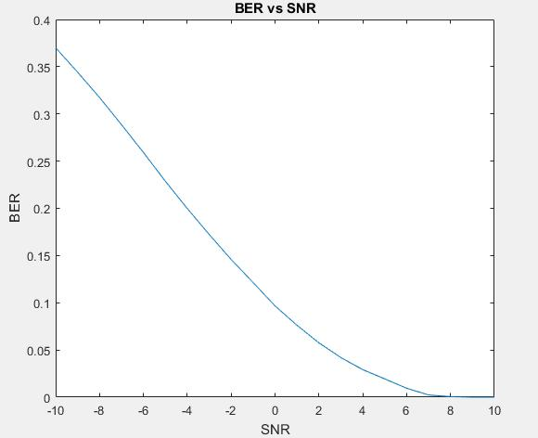

1. Part II

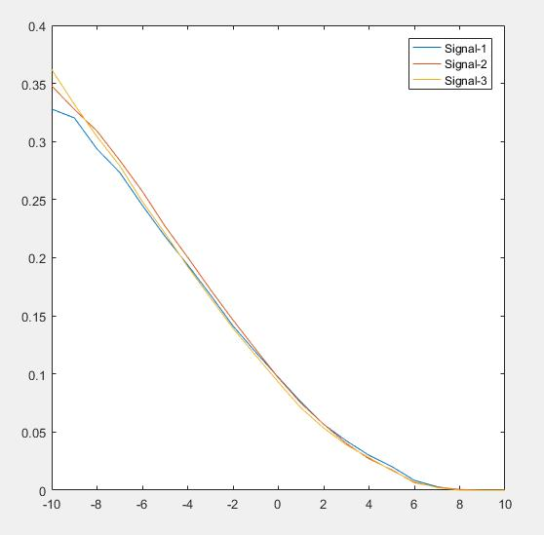

**CONCLUSION**

In this practical we have seen the CDMA spreading and despreading techniques and we also plotted BER vs SNR for three messages.

**U19EC046 | WMC | LAB 6**

**AIM**

To Simulate Equalization Techniques using AWGN channel considering input as any random data as well as an Image with the help of MATLAB software. Also compare output of both with and without equalization.

**THEORY**

With the growth in wireless communication, there was a requirement to improve the received signal quality because there were a number of channels working at different frequencies which cause signal fading and interference. Thus techniques were evolved to improve received signal of quality. These techniques are ‘Equalization and Diversity’. Equalization is used to compensate intersymbol interference (ISI) while Diversity is used to compensate for fading.

An equalizer is usually implemented at base band or at IF stage in a receiver. Adaptive equalizer works on two operating modes, that are training and tracking. A fixed length training sequence is sent by the transmitter so that the receiver’s equalizer may receive the signal for minimum bit error rule (BER). This sequence is a pseudo random binary signal followed by the user data.

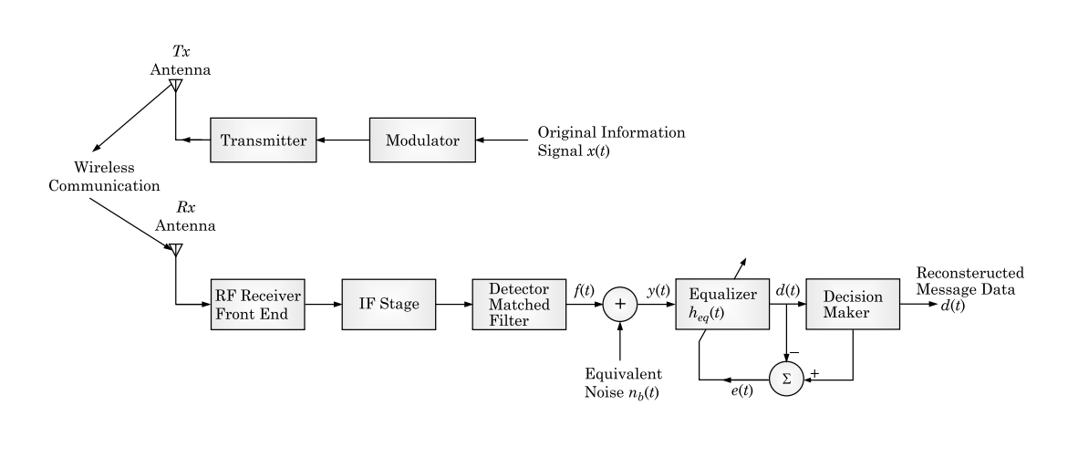

**Block diagram of a Communication system using an equalizer**

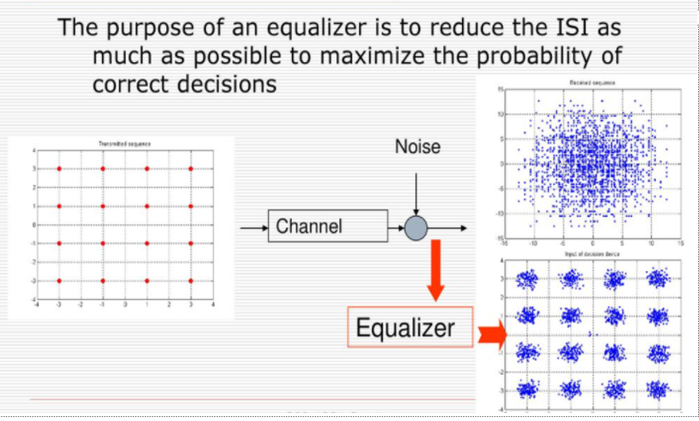

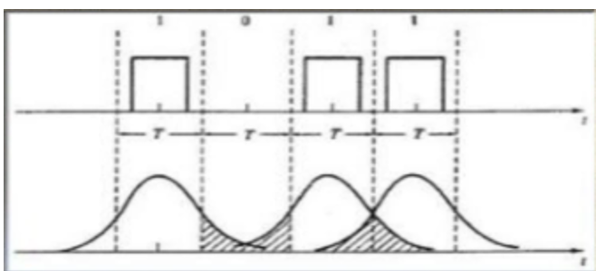

**Inter Symbol Interference (ISI)**

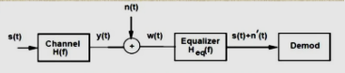

**Matlab Implementation**

**ALGORITHM:**

* Input the random data (Let say 1000 in number)
* Change into required format.
* Modulate it with psk
* Assume SNR
* Add AWGN
* Assume Tau and PdB
* Assume Rayleigh channel
* Realize it with filter function
* Assume LMS as adaptive algorithm object
* Construct linear equalizer object (lineareq)
* Equalize signal using equalizer object (equalize)
* Demodulate the data
* Convert it into required format
* Find BER
* Compare output for both with and without equalizer (Repeat steps 12-14 for without equalizer)
* Repeat the above procedure for input as an image

**MATLAB CODE**

|  |
| --- |
| ***% Set up parameters and signals.***  **M = 4; *% Alphabet size for modulation***  **data = randi([0 1], 5000, 1);**  **[n, m] = size(data);**  **Mod=2;**  **data_vector = reshape(data, [numel(data)/Mod Mod]);**  **msg = bi2de(data_vector);**  **hMod = comm.QPSKModulator('PhaseOffset',0);**  **modmsg = step(hMod,msg); *% Modulate using QPSK.***  **trainlen = 200; *% Length of training sequence***  **Tauj = [0.986 0.845 0.237 0.123];**  **Beta = [-0.1 0 -0.03 0.31];**  **chan = rayleighchan(1,0,Tauj, Beta);**  **chanCoeff = chan.AvgPathGaindB + 1i*chan.PathDelays;**  **filtmsg = filter(chanCoeff,1, modmsg); *% Introduce channel distortion.***  ***% Equalize the received signal.***  **eq1 = lineareq(8, lms(0.01)); *% Create an equalizer object.***  **eq1.SigConst = step(hMod,(0:M-1)')'; *% Set signal constellation.***  **[symbolest,yd] = equalize(eq1,filtmsg,modmsg(1:trainlen)); *% Equalize.***  **scatterplot(filtmsg)**  **legend('Filtered signal')**  **scatterplot(symbolest)**  **legend('Equilized signal')**  ***% Compute error rates with and without equalization.***  **hDemod = comm.QPSKDemodulator('PhaseOffset',0);**  **demodmsg_noeq = step(hDemod,filtmsg); *% Demodulate unequalized signal.***  **demodmsg = step(hDemod,yd); *% Demodulate detected signal from equalizer.***  **hErrorCalc = comm.ErrorRate; *% ErrorRate calculator***  **ser_noEq = step(hErrorCalc, ...**  **msg(trainlen+1:end), demodmsg_noeq(trainlen+1:end));**  **reset(hErrorCalc)**  **ser_Eq = step(hErrorCalc, msg(trainlen+1:end),demodmsg(trainlen+1:end));**  **disp('Symbol error rates with and without equalizer:')**  **disp([ser_Eq(1) ser_noEq(1)])** |

**OUTPUT**

1.

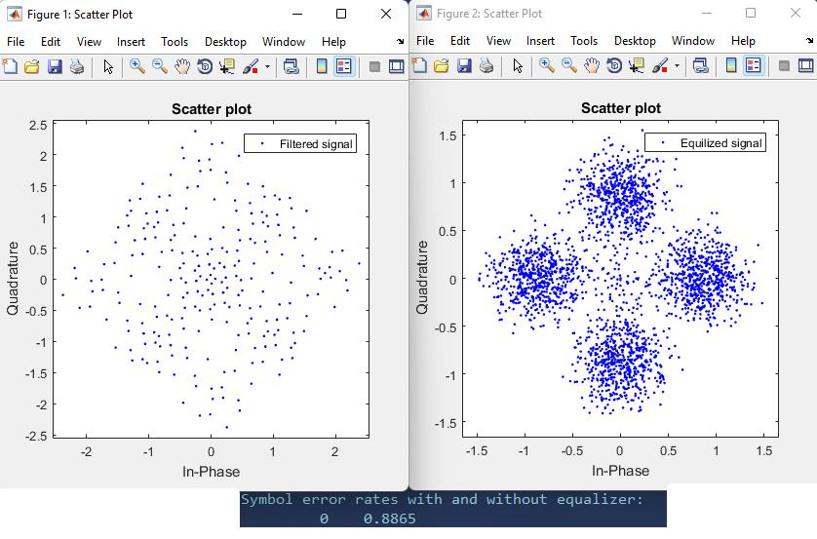

**CONCLUSION**

In this practical we have implemented using matlab with AWGN channel under Rayleigh fading. It was observed that error rate was reduced after using equalization methods.

**U19EC046 | WMC | LAB 7**

**AIM**

To understand the pathloss prediction formula.

-> Calculation of received signal strength as a function of distance of separation between transmitter and receiver.

-> To understand the impact of the following parameters on received signal strength.

* Transmitter Power,
* Pathloss exponent,
* Carrier frequency,
* Receiver antenna height,
* Transmitter antenna height.

**THEORY**

The design of a communication system involves selection of values for several parameters. One of the important parameter is the transmit power. Higher transmit power ensures large allowable separation distance between the transmitter (Tx) and receiver (Rx). Of course the loss in signal power per unit distance depends on the properties of the medium. In case of wireless communication on one hand it is desired to have a very large coverage (large allowable separation between Tx and Rx) on the other hand it is also desired that co-channel interference be as low as possible. An understanding of the large scale propagation effects is very important for design of suitable communication system. In terrestrial mobile communication system, electro-magnetic wave propagation is affected by reflection, diffraction and scattering. These lead to dynamic variation of signal strength as a function of time, frequency, distance of separation, antenna height, antenna configuration, local scattering environment etc. Propagation models are necessary in order to predict the received signal strength for a given set of parameters as mentioned above. These models can be broadly considered under:-

* Large scale Fading Model.
* Small Scale Fading Model.

**1.1 Large Scale Fading:-**

Large Scale Fading is dealt by propagation models that predict the mean received signal strength for an arbitrary transmitter receiver separation. The large scale fading model gives such an average with measurements across 4λ to 40λ, where λ is the wavelength. This is useful for estimating coverage area. Large Scale fading can be broadly classified as:-

* Path Loss.
* Shadowing.

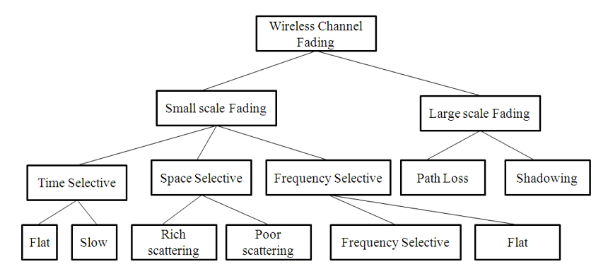

Large scale fading is heavily affected by power dissipation and effects of the propagation channels. The models assume some path loss at a given distance between Tx and Rx i.e. there is no shadowing. It is useful in getting a quick estimate of the average signal strength, hence the coverage. These models are used for prediction of signal variation across 100m-1000m.

There have been ray tracing methods which are complicated and are useful for static scenarios. In case of dynamic scenarios statistical models are used. A statistical model ensures that the statistical properties of the numbers generated using the model matches the recorded values.

We begin with Friis Free space propagation loss. The received power at a distance'd' is given by.

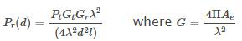

Pt=Transmitter Power.

Pr(d)=Received power at a distance'd'.

Gt=Transmit antenna power gain.

Gr=Received antenna power gain.

λ=Wavelength.

Ae=Effective aperture related to the physical size of antenna.

L≥1 System loss factor not related to propagation .  
Transmission line , Filter losses, Antenna loss etc .

D=Tx−Rx separation distance.  
PrPrdecrease as square of distance 20 dB/ decade.

Path loss gives a measure of signal attenation. It is usually measured in dB.It is defined as a difference between the transmitted antenna gains.

The path loss for free space model is

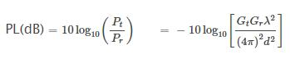

It may be remembered that Friis free space model is valid for 'd' in the far field of the transmission antenna. The far field / Fraunhofer region is beyond the far field distance, where df=(2D2)/λ

It is related to the largest linear dimension of the antenna aperture and carrier wavelength. d is the largest linear distance of the antenna. df>>d and df>>λ then it is the far field region. For path loss models 'd' can't be 0.  
Therefore a close in distance is used which is known as the received power reference point .Thus Pr(d) for d>d0 may be reference to Pr(d0) where Pr(d0)may be predicted from Friis free space propagation loss model. It may also be obtained from measurements by using average of several recordings at distance d0. The distance d0>>df but d0d0 is sufficiently smaller than practical BS-MS distance.



Usually received signal strength is measured in dBm or dBw.

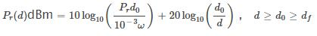

Where Pr(d0) is in watt.

The Value d0d0 in 1-2 GHz.

~1m for indoor condition.

~100m//1km for indoor condition.

The received power predicted by path loss models is influenced by

**Reflection:** Reflection occurs when the propagation waves impinge on objects with dimension larger than λ.

**Diffraction:** Diffraction is caused by sharp irregularities in the path of radio waves. It leads to development of secondary wave fronts, bending of waves. It is caused by objects which are in order in λ. It depends on geometry of the objects, amplitude, phase and polarization of incident waves.

**Scattering:** Scattering is caused by objects which are smaller than λ.

Using the famous 2-Ray propagation model [Ref(Rappaport)] . It can be shown that when a transmitter at height htht transmit with power Pt having antenna gain Gt the receiver signal power at the receiver located at height hrhr using an antenna with gain GrG and located at a distance 'd' from the transmitter given by

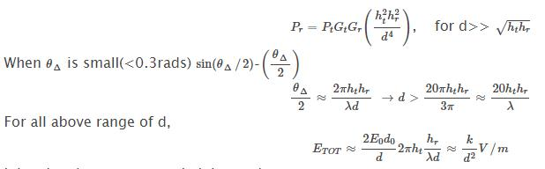\

k is related to E0,antenna heights and λ

Power received is proportional to square of electric field.

Therefore received power from transmitter at a distance d is

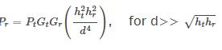

Power deceases with fourth power d → 40dB/decade

The pathloss for the 2 Ray model is given by



In general the PL and d−nr is the pathloss exponent. The value of np can be obtained analytically/emperically.

Emperically models have the advantage of taking all factors into account (both known and unknown).It is based on actual field measurement.  
Its disadvantage is that it is valid for only the measured frequency and location. Generally

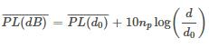

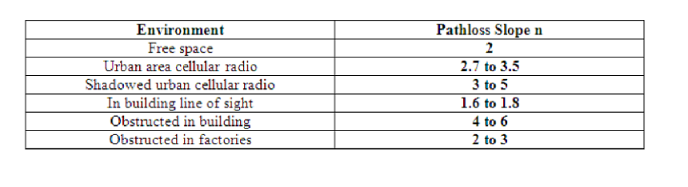

Pathloss models are defined for:

Indoor office test environment

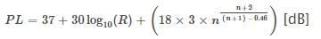

* R=transmitter-receiver Seperation.
* n=no. of floor in the path.
* L shall in all cases > free space loss.

Outdoor to indoor and pedestrian testr environment(base model)

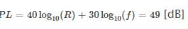

* R= base station to mobile station deviation [Km],
* f= carrier frequency [MHz], reference 2000 MHz.

Vehicular test environment



* R= base station to mobile station deviation [Km],
* f= carrier frequency [MHz], reference 2000 MHz.
* Hb = Base station height[m] above average roof top level.

Path Loss deals with the propagation loss due to distance between transmitter and receiver while shadowing describes variation in the average signal strength due to varying environmental clutter at different locations.

This experiment is on Path Loss Models.

**1.2 Important Formulas:-**

These two formulas are for calculating the received signal strength and path loss exponent. These two formulas are applicable for EXPT 1A and EXPT 1B.

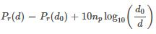

Where,

* Pr(d)=received signal strength for a certain Tx−-Rx separation distance,
* d = certain Tx−-Rx separation distance in meters,
* Pr(d−0)=received signal strength at a close-in-reference-distance,
* d0=close-in reference distance from transmitter in meters.

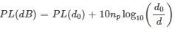

Where,

npnp=the path loss exponent.

**1.3 Advanced Formula:-**

This advanced formula given below calculates the path loss for a particular application and captures the effect of base station antenna height, receiver antenna height and carrier frequency.



Where,

* d=Tx−-Rx,i.e.,Tx and Rx separation distance in meters.
* hBS = the base station antenna height in meters.
* hUT== the user terminal i.e. receiver antenna height in meters.
* fc is the carrier frequency in GHz.

This formula is applicable for EXPT 1C, 1D, 1E.

**OBSERVATION TABLES:**

**Experiment A** - Calculation of Received Power at a certain Tx-Rx separation distance

|  |  |  |  |
| --- | --- | --- | --- |
| **Pr(d0)**  **(dBm)** | **Distance d**  **(m)** | **Distance d0**  **(m)** | **Pr(d)**  **(dBm)** |
| -11.76 | 500 | 70 | -28.84 |
| -24.53 | 1064 | 76 | -47.45 |

**Experiment B –** Calculating the path loss exponent

|  |  |  |  |  |  |
| --- | --- | --- | --- | --- | --- |
| **Tx Power**  **(dBm)** | **Pr(d0)**  **(dBm)** | **Distance d0**  **(m)** | **Distance d**  **(m)** | **Pr(d)**  **(dBm)** | **Path Loss**  **Exponent** |
| 33 | -18.9 | 92 | 836 | -59.63 | 4.25 |
| 33 | -22.86 | 89 | 500 | -56.07 | 4.43 |

**Experiment C -** Calculating Carrier Frequency (fc)

|  |  |  |  |  |  |  |
| --- | --- | --- | --- | --- | --- | --- |
| **Distance**  **(m)** | **Pr(d)**  **(dBm)** | **Transmitter Power**  **(dBm)** | **Height of Transmitter**  **(m)** | **Height of Receiver**  **(m)** | **Path Loss**  **Exponent** | **Carrier Frequency**  **(fc)(GHz)** |
| 100 | -41.61 | 36 | 30 | 1 | 4.23 | 3.89 |
| 908 | -77.13 | 50 | 30 | 1 | 4.57 | 3.44 |
| 472 | -25.16 | 50 | 30 | 1 | 3.3 | 1.93 |
| 716 | -51.46 | 33 | 52 | 6 | 4.19 | 1.25 |

**Experiment D -** Calculating Receiver Antenna Height

|  |  |  |  |  |  |  |
| --- | --- | --- | --- | --- | --- | --- |
| **Distance**  **(m)** | **Pr(d)**  **(dBm)** | **Transmitter Power**  **(dBm)** | **Height of Transmitter**  **(m)** | **Path Loss**  **Exponent** | **Carrier Frequency**  **(fc)(GHz)** | **Height of Receiver**  **(m)** |
| 100 | -2.66 | 36 | 30 | 3.02 | 2.3 | 3.68 |
| 908 | -62.47 | 50 | 30 | 4.72 | 2 | 6.3 |
| 472 | -24.54 | 33 | 30 | 3.1 | 2 | 5 |
| 716 | -62.06 | 33 | 33 | 4.24 | 2 | 4.93 |

**Experiment E -** Calculating BS Antenna Height

|  |  |  |  |  |  |  |
| --- | --- | --- | --- | --- | --- | --- |
| **Distance**  **(m)** | **Pr(d)**  **(dBm)** | **Transmitter Power**  **(dBm)** | **Height of Receiver**  **(m)** | **Path Loss**  **Exponent** | **Carrier Frequency**  **(fc)(MHz)** | **Height of Transmitter**  **(m)** |
| 100 | -25.24 | 36 | 1 | 3.62 | 2.4 | 29.91 |
| 908 | -83.81 | 50 | 1 | 4.97 | 2 | 31.73 |
| 472 | -59.73 | 33 | 6 | 4.53 | 2 | 36.91 |
| 716 | -58.02 | 46 | 6 | 4.53 | 2.4 | 30.41 |

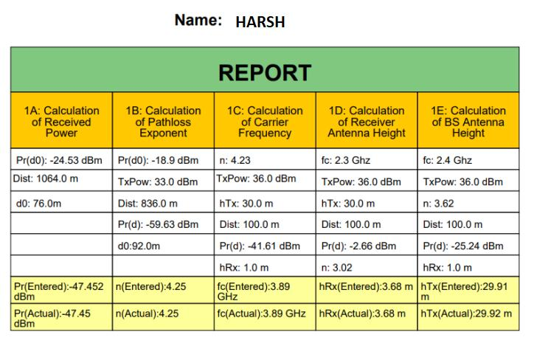

**CONCLUSION**

In this practical we calculated various path loss components using Visual Lab and verified the calculated and the observed values from the table which are identical to each other. We calculated the path loss component for various cases which are the Received Power, Path Loss Exponent, Carrier Frequency, Receiver Height and Transmitter Height.

**U19EC046 | WMC | LAB 8**

**AIM**

To understand the cellular frequency reuse concept fulfilling the following objectives:

1. Finding the co-channel cells for a particular cell.
2. Finding the cell clusters within certain geographic area.

**THEORY**

In mobile communication systems a slot of a carrier frequency / code in a carrier frequency is a radio resource unit. This radio resource unit is assigned to a user in order to support a call/ session. The number of available such radio resources at a base station thus determines the number of users who can be supported in the call. Since in wireless channels a signal is "broadcast" i.e. received by all entities therefore one a resource is allocated to a user it cannot be reassigned until the user finished the call/ session. Thus the number of users who can be supported in a wireless system is highly limited.

In order to support a large no. of users within a limited spectrum in a region the concept of frequency re-use is used.

The signal radiated from the transmitter antenna gets attenuated with increasing distance. At a certain distance the signal strength falls below noise threshold and is no longer identifiable.

In this region when the signal attenuates below noise floor the same radio resource may be used by another transmission to send different information. In term of cellular systems, the same radio resource (frequency) can use by two base stations which a sufficient spaced apart. In this way the same frequency gets reused in a layer- geographic area by two or more different base station different users simultaneously.

Now what is important is to select the set of base stations which will use the same set of radio resources/ channel of frequencies or technically the co- channel cells.

In this context the minimum adjacent set cells which use different frequencies each is calls a cluster.

The cellular concept is the major solution of the problem of spectral congestion and user capacity. Cellular radio relies on an intelligent allocation and channel reuse throughout a large geographical coverage region.

**Cellular Frequency Reuse:**

Each cellular base station is allocated a group of radio channels to be used within a small geographic area called a cell. Base stations in adjacent cells are assigned channel groups which contain completely different channels than neighboring cells. Base station antennas are designed to achieve the desired coverage within a particular cell. By limiting the coverage area within the boundaries of a cell, the same group of channels may be used to cover different cells that are separated from one another by geographic distances large enough to keep interference levels within tolerable limits. The design process of selecting and allocating channel groups for all cellular base stations within a system is called frequency reuse or frequency planning.

**Hexagonal Cell Structure:**

In figure 1, cells labeled with the same letter use the same group of channels. The hexagonal cell shape is conceptual and is the simplistic model of the radio coverage for each base station. It has been universally adopted since the hexagon permits easy and manageable analysis of a cellular system. The actual radio coverage of a system is known as the footprint and is determined from old measurements and propagation prediction models. Although the real footprint is amorphous in nature, a regular cell shape is needed for systematic system design and adaptation for future growth.

If a circle is chosen to represent the coverage area of a base station, adjacent circles overlaid upon a map leave gaps or overlapping regions. A square, an equilateral triangle and a hexagon can cover the entire area without overlap and with equal area. A cell must serve the weakest mobiles typically located at the edge of the cell within the foot print. For a given distance between the center of a polygon and its farthest perimeter points, the hexagon has the largest area of the three. Thus, with hexagon, the fewest number of cell scan cover a geographic region and close approximation of a circular radiation pattern that occurs for an Omni directional base antenna and free space propagation is possible.

Base station transmitters are situated either at the center of the cell (center-excited cells) or at three of the six cell vertices (edge-excited cells). Normally, omnidirectional antennas are used in center-exited cells and sectored directional antennas are used in edge-exited cells. Practical system design considerations permit a base station to be positioned up to one-fourth the cell radius away from the ideal location.

**Cell Cluster:**

Considering a cellular system that has a total of S duplex radio channels. If each cell is allocated a group of k channels and (k<S) if the S channels are divided among N cells into unique and disjoint channel groups of same number of channels, then,

S=kN

The N cells that collectively use the complete set of available frequencies are called a cluster. If a cluster is replicated M times within the system, the total number of duplex channels or capacity,

C=MkN=MS

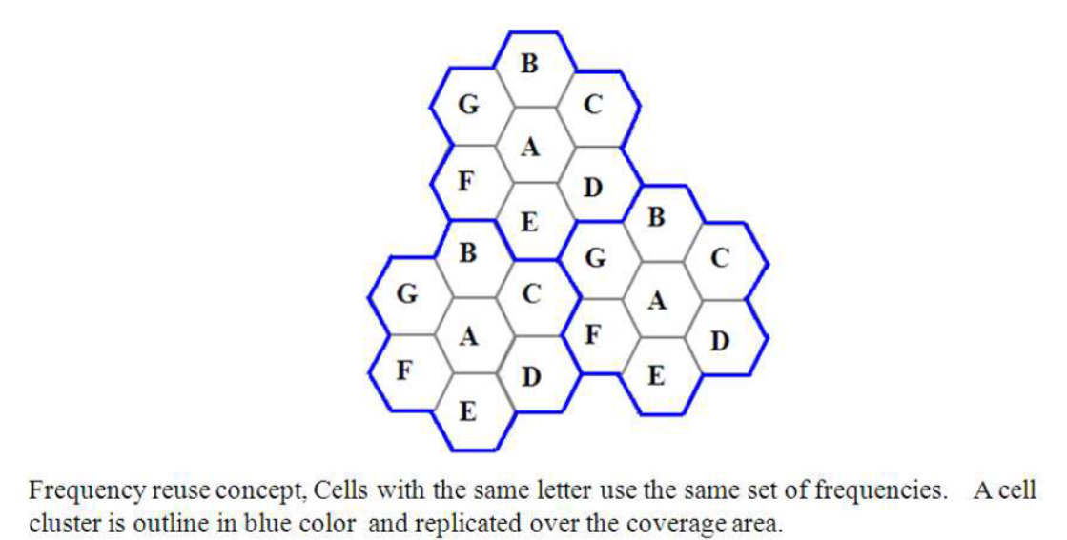

**Co-channel Cells:**

A larger cluster size causes the ratio between the cell radius and the distance between co-channel cells to decrease reducing co-channel interference. The value of N is a function of how much interference a mobile or base station can tolerate while maintaining a sufficient quality of communications. Since each hexagonal cell has six equidistant neighbors and the line joining the centers of any cell and each of its neighbors are separated by multiples of 60 degrees, only certain cluster sizes and cell layouts are possible. To connect without gaps between adjacent cells, the geometry of hexagons is such that the numbers of cells per cluster, N, can only have values that satisfy,

In this example,N = 19 (i.e., i = 3, j = 2).

Where, i and j are non-negative integers.

To find nd the nearest co-channel neighbours of a particular cell,

a. move i cells along any chain of hexagons then,

b. turn 60 degrees counter-clockwise and move j cells.

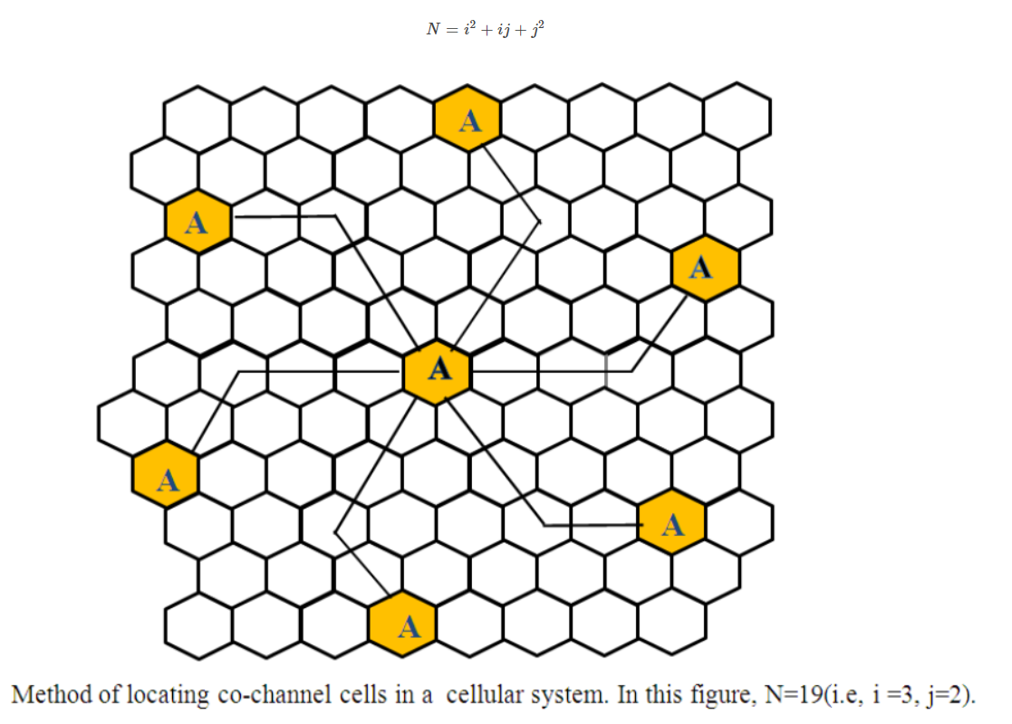

**OUTPUTS**

**Part 1**

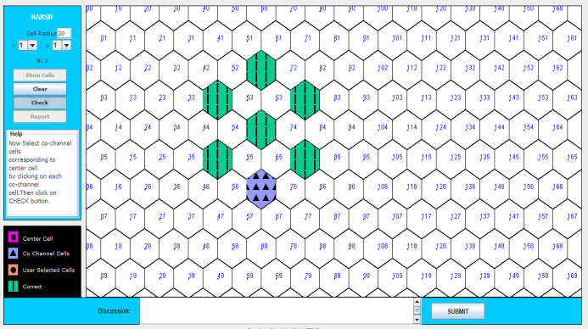

**Part 2**

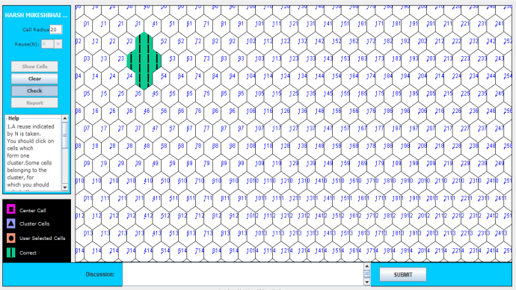

**CONCLUSION**

In this experiment we pointed out the co-channel cells for a “particular cell by moving i cells along any chain of hexagons then, turn 60 degrees counter-clockwise and move j cells” and cells of a cell cluster within certain geographic area using IIT Kharagpur Visual Lab and we can conclude that in order to support a large no. of users within a limited spectrum in a region the concept of frequency re-use is used and a larger cluster size causes the ratio between the cell radius and the distance between co-channel cells to decrease reducing co-channel interference. The value of N is a function of how much interference a mobile or base station can tolerate while maintaining a sufficient quality of communications.

**U19EC046 | WMC | LAB 9**

**AIM**

To Perform QPSK and QAM modulation Techniques using ScienTech Trainer Kit.

**Practical 9.1**

**Aim**

To Perform QPSK modulation Technique using ScienTech Trainer Kit.

**Apparatus**

ST 2112 QAM Trainer Kit

CRO

CRO Probes

**Procedure**

1. Ensure the following initial conditions on ST2112 trainer: Power supply and SW3, SW5, SW6, SW7, SW9 should be in the OFF mode.
2. Switch on the power supply.
3. Connect Test point TP6 on Channel 1 & TP7 on Channel 2 of Oscilloscope; you will observe 1 KHz sine & cosine wave.
4. Set I & Q Channel data with the help of DIP switch SW5, SW6, SW7. As there are 24 bits data available on the trainer so, first bit is I bit then second bit is Q bit then third bit is C bit. But in this experiment you have to use I bit & Q bit so you can select combination according to your requirement.

For example:

SW5=11000010

SW6=01001010

SW7=00100010

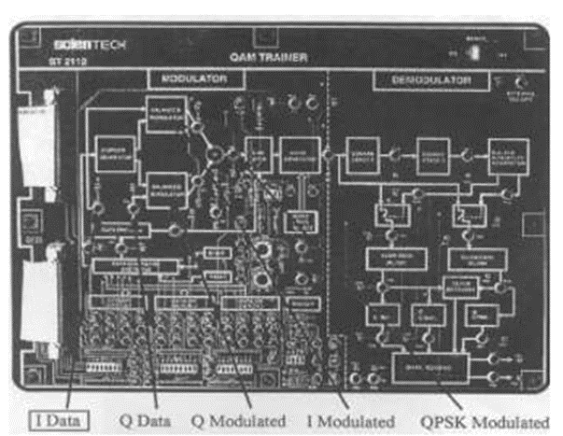

Fig 1. QPSK (Quadrature phase shift keying)

1. Switch ON all the DIP switches on SW3.
2. Now press SW8 which is reset switch then press SW4 which is start.
3. Now connect Channel 1 of Oscilloscope to TP2 & Channel 2 to TP1, you can observe Clock & Data which you have set.
4. Now to observe QPSK modulated signal with respect to data connect Channel 1 to TP1 & Channel 2 to TP8. You can observe QPSK modulated signal with respect to data.
5. Turn OFF the power.

Two 1 KHz sine carriers, shifted between them of 90°, are separately applied to two balanced modulators. The data (signals I and Q) reach the two modulators from the bit generator. Each modulator provides the direct sine-wave when the data signal is to low level (bit “0”), the inverted sine-wave (shifted of 180°) when the bit is “1”. By adding the two outputs you get a 1 KHz sine signal, which phase can take 4 different values separated of 90° between them.

**Block Diagram**

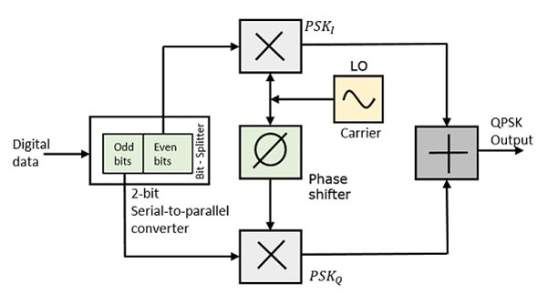

**Waveforms And Constellation Diagram**

*Clock and Data*

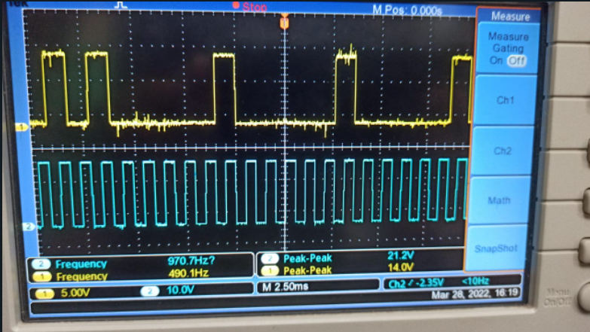

*Data and QPSK*

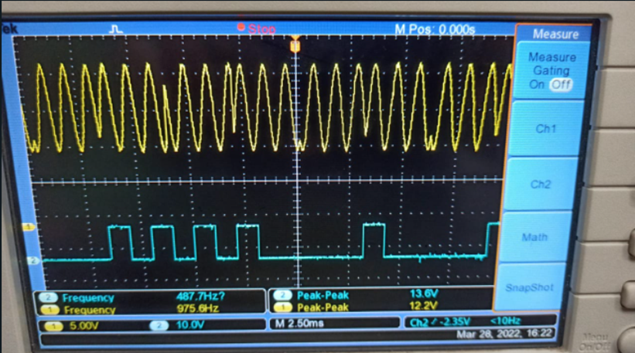

*Input I and Output I(y)*

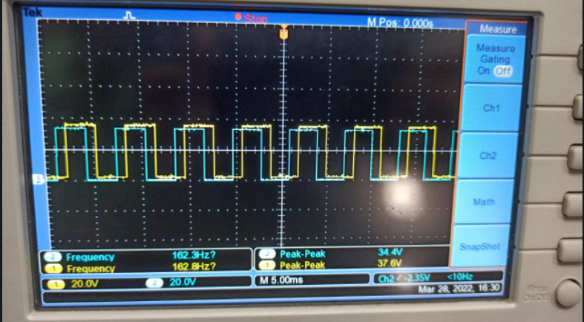

*Input q and Output Q(y)*

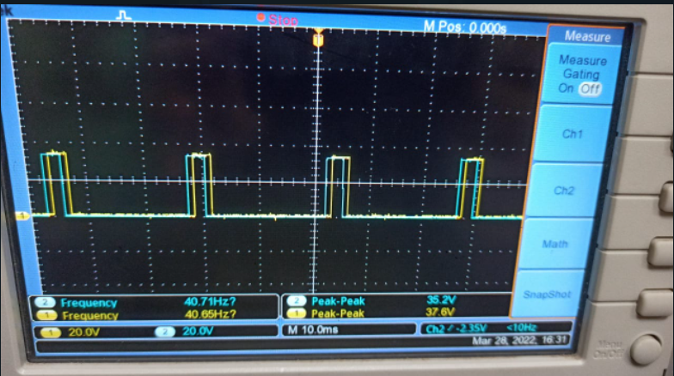

*Constellation Diagram*

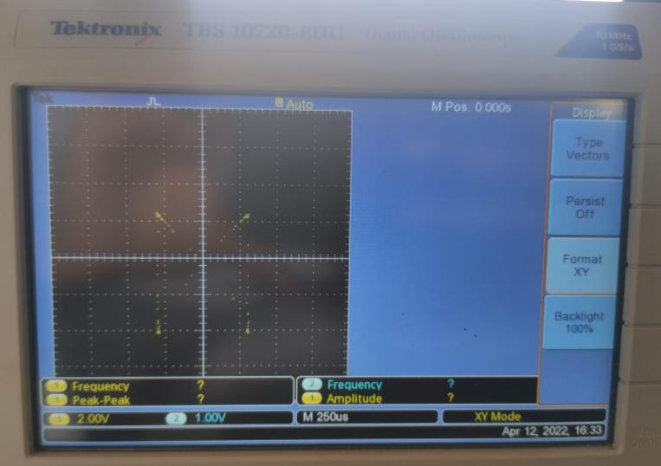

**Conclusion**

In this experiment, we studied and implemented QPSK on ST 2112 QAM Trainer Kit and got the Constellation Diagram on DSO.

**Practical-9.2**

**Aim**

To Perform QAM modulation Technique using ScienTech Trainer Kit.

**Apparatus**

ST 2112 QAM Trainer Kit

CRO

CRO Probes

**Theory**

The QAM is a digital modulation where the information is contained into the phase as well as the amplitude of the transmitted carrier.

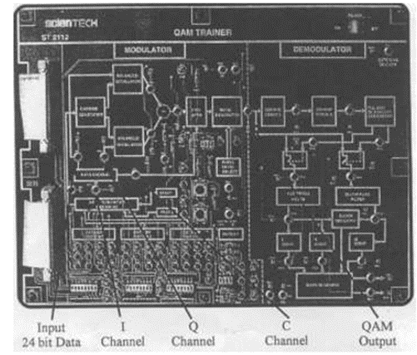

Fig.1 QAM Modulation Kit

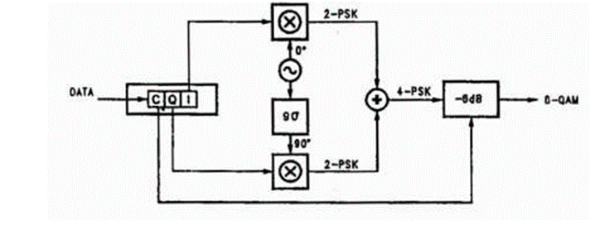

Fig.2 (Block Diagram)

**8-QAM**

In the 8-QAM the data are divided into groups of 3 bits (Tri bit), one of which varies the amplitude of the carrier, the last two the phase. The modulated signal can take 4 different phases and 2 different amplitudes, for a total of 8 different states.

**16-QAM**

In the 16-QAM the data are divided into groups of 4 bits (Quad bit). The 16 possible combinations change amplitude and phase of the carrier, which can take 16 different states.

**Procedure**

1. Ensure the following initial conditions on ST2112 trainer: Power supply and SW3, SWS, SW6, SW7 and SW9 should be in the OFF mode.
2. Switch on the power supply.
3. Connect Test point TP6 on Channel 1 & TP7 on Channel 2 of Oscilloscope; you will observe 1 KHz sine & cosine wave.
4. Set I, Q & C Channel data with the help of DIP switch SW5, SW6, SW7. As there are 24 bits data available on the trainer so, first bit is I bit then second bit is Q bit then third bit is C bit. For example:

SW5=11000110

SW6=01011000

SW7=01100010

1. Switch ON all the DIP switches on SW3.
2. Now press SW8 which is reset switch then press SW4 which is start.
3. Now connect Channel 1 of Oscilloscope to TP2 & Channel 2 to TP1, you can observe Clock & Data which you have set. (If you are using logic analyzer then you are able to see all 24 bits)
4. Now to observe QAM modulated signal with respect to data, connect Channel 1 toTP1 & Channel 2 to TP9.
5. You can add noise by using DIP switch SW9 (001/010/111).
6. To observe the demodulator section, connect channel 1 of oscilloscope to the test point TP 12 you will observe squarer frequency.
7. To observe I switch & Q switch in the demodulator section, connect channel 1 of oscilloscope to TP 16 & channel 2 of the oscilloscope to TP 17.
8. To observe I, Q & C demodulated signal connect oscilloscope to TP 2O, TP 21, TP 22 (if you have logic analyzer you can observe I, Q & C simultaneously).
9. To observe decoded data you have to connect oscilloscope channel 1 to TP 23 & channel 2 to TP 24.
10. Turn OFF the Power.

**Waveforms And Constellation Diagram**

*Data and QAM*

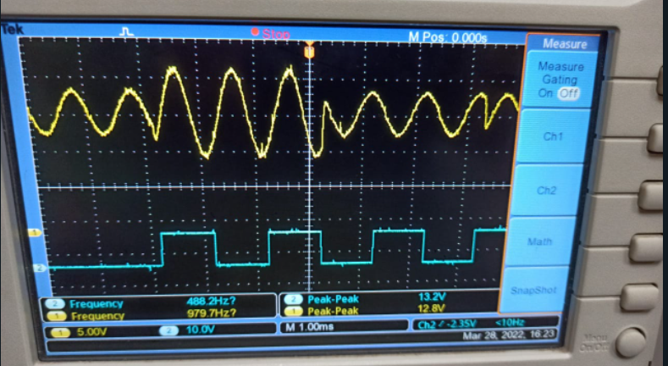

*Constellation Diagram*

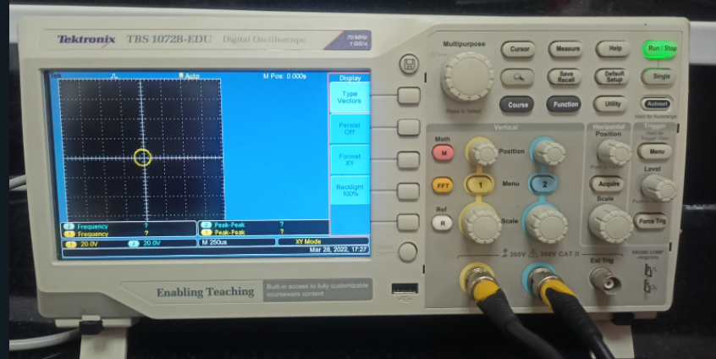

**Conclusion**

In this experiment, we studied and implemented QAM on ST 2112 QAM Trainer Kit and got the Constellation Diagram on DSO

**U19EC046 | WMC | LAB 10**

**PRACTICAL-10**

**Aim**

Study of Direct Sequence Spread Spectrum(DSSS) Modulation and Demodulation process.

**Practical-10.1**

**Aim**

Study of Spreading and Despreading based on Spread Spectrum Technique.

**Apparatus**

ST 2115 CDMA Trainer Kit

CRO

CRO Probes, Patch Codes

**Procedure**

Refer to the figure 1. while configuring setup for the experiment.

1. Switch data switches to 1 or 0 as per your choice of binary data pattern.
2. Connect any two of the four taps viz. A, B, C or D to the inputs of EX-OR gate of PN sequence generator. Connect 240 KHz clock signal on board to the clock input of the PN sequence generator.
3. Now switch ON the power supply and observe the output of Binary Data Generator and PN sequence generator. Since the data generator frequency used here is 30 KHz and that of PN Sequence Generator is 240 KHz, and hence there are 8 PN sequence bits per data bits for spreading the binary signal.

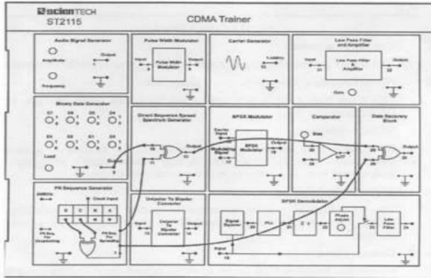

Fig 1. Spreading and Despreading Set Up

1. Change the positions of taps for feedback in the PN Sequence Generator Block to obtain deferent patterns of the PN sequences. Now, switch OFF and then ON the power supply to reload the changes, if changes do not appear in the output on changing the tap positions.
2. Connect output of binary data generator to one of the inputs of Direct Sequence Spread Spectrum generator input.
3. Connect output of PN sequence generator to the other input of DSSS EX-OR gate.
4. Now turn ON power supply and observe the output of DSSS generator block. This is our DSSS signal.
5. Now connect output of this DSSS block to the one of the inputs of EX-OR gate of Data Recovery Block. Connect the same output of PN sequence generator, which we have taken for spreading to the other input of this recovery gate for despreading. Note that the PN sequence used for dispreading is taken from the same output pin from where the PN sequence is taken for spreading the signal. This is because of the fact that there is complete synchronization between the spread signal and PN sequence. In other words there is not any significant delay involved in spreading process.
6. Observe the output of this data recovery block. This is recovered output without almost any error.
7. Now change the tape positions of shift registers (A, B, C or D) to get a new PN sequence and repeat the above process again. Thus you will observe that with each different sequence we are quite able to recover the original data also with different PN sequences, the modulated (Spread) data looks different i.e. we can recover the data if and only if we are using the same PN sequence for both modulation and demodulation. This is the reason that this DSSS technique has a large potential for being a multiple access technique. This multiple access technique is known as “Code Division Multiple Access” (CDMA) technique.

**Waveforms**

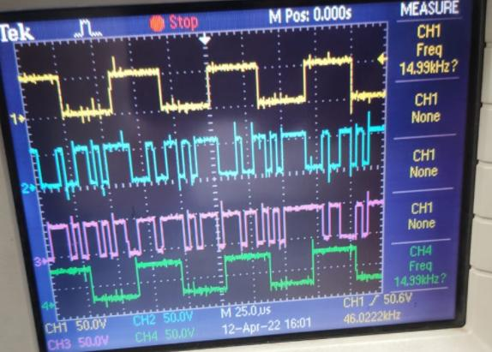

**Conclusion**

We were able to understand and perform spreading and dispreading based on spread spectrum technique using CDMA Trainer kit.

**Practical-10.2**

**Aim**

Study of Direct Sequence Spread Spectrum(DSSS) Modulation/Demodulation using an Analog signal and Digital signal as inputs individually.

**Apparatus**

ST 2115 CDMA Trainer Kit

CRO

CRO Probes, Patch Codes

**Procedure for Analog Signal**

1. Make the connections as shown in the figure 1.

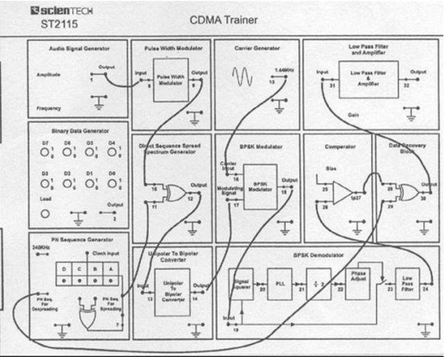

Fig 1. DSSS Set Up

1. Observe the output of audio signal generator block.
2. Observe the output of DSSS block.
3. Observe the output of BPSK modulator.
4. Observe the output of data recovery block. Adjust phase of recovered carrier and bias of comparator until you see an exact replica of pulse width modulated data at the output of this recovery block.
5. Observe the output of low pass filter section and compare it with the input Audio signal. Change gain of the amplifier to remove any nonlinearity errors. If still output is not proper then change amplitude of the input audio signal and adjust the gain of the output amplifier to remove distortions.

**Procedure for Digital Signal**

Refer to the figure 2 while configuring setup for the experiment.

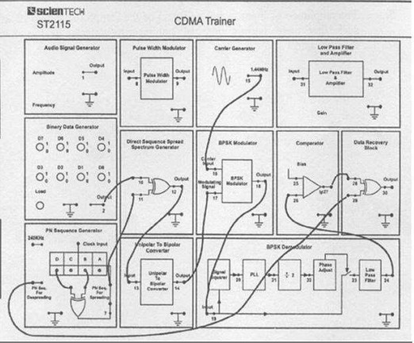

Fig 2. CDMA Trainer Set Up

1. Switch data switches to 1 or 0 as per your choice of binary data pattern.
2. Connect any two of the four taps viz. A, B, C, or D to the inputs of EX-OR gate of PN Sequence generator. Connect 240 KHz clock signal on board to the clock input of the PN sequence generator.
3. Now switch ON the power supply and observe the output of Binary Data generator and PN sequence generator. Since the data generator frequency used here is 30 KHz and that of PN Sequence Generator is 240 KHz, and hence there are 8 PN sequence bits per data bits for spreading the binary signal.
4. There are two outputs of PN Sequence Generator shown on the board. One of the outputs is for spreading the binary data signal and the other one is for dispreading the coded signal to recover back the original data(when BPSK modulation is used for RF modulation of Spread signal).
5. Connect binary data and PN sequence outputs to the EX-OR gate of DSSS block. Connect the output of DSSS block to the input of unipolar to bipolar converter. Take the output of this converter to the input of BPSK modulator. Connect sinusoidal carrier from Carrier Generator to the carrier input of BPSK modulator. This completes the modulator connections.
6. Now connect output of BPSK modulator to the input of BPSK demodulator block. Connect output of this block to the comparator input. Here we would receive original chipped data.
7. Connect the recovered chipped data (output of comparator) to one of the inputs of data recovery block. Connect ‘PN Sequence for Dispreading’ output of PN sequence generator block to the other input of data recovery gate.
8. Now turn power supply ON. Observe data and PN Sequence at their respective output pins. Press load button if data is not appearing.
9. Observe the output of DSSS block. This is called ‘Chipped Data’.
10. Observe the output of BPSK modulator. This is RF modulated chipped data.
11. Observe the output of comparator and then Data Recovery Block. Adjust phase of recovered carrier in BPSK modulator section and bias of comparator until you see a complete replica of original binary data.
12. Change data pattern and repeat the whole procedure with this new data. Again adjust phase and bias of comparator so as to recover the data completely.
13. Change chip (PN Sequence) pattern and observe the results.

**Waveforms**

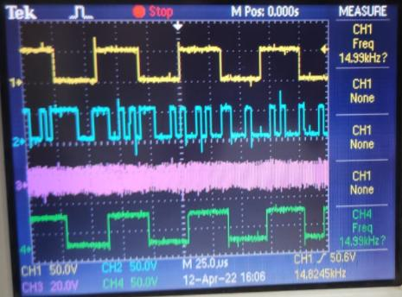

**Conclusion**

We were able to understand and perform the Direct Sequence Spread Spectrum modulation and demodulation using CDMA by taking analog and digital signals as inputs.

**U19EC046 | WMC | LAB 11**

**Aim**

To study about Software Defined Radio

**Theory**

***Introduction of GNU based Software Defined Radio (SDR):***

Software Defined Radio (SDR), sometimes shortened to software radio (SR), was introduced for the first time in 1991 by Joseph Mitola. The word of SDR was used to show a radio class that could be re-configured or re-programmed, thus resulted a kind application of wireless communication with mode and frequency band determined by software function. Ideally, SDR offers flexibility, re-configurability, scalability and as multi-mode as possible. SDR architecture is developed based on conventional radio functions. The difference is all functions of signal processing on conventional radio are carried out fully by hardware while the functions of signal processing on SDR are carried out as much as possible by software. The major key in building SDR is the placement of ADC and DAC components as a divider between analog and digital domain, thus the signal processing can be carried out using software.

The more realistic SDR architecture places ADC/DAC wideband after Down Converter/Up Converter, thus the conversion from analog to digital or its reverse is carried out on Intermediate Frequency (IF) signal which possesses lower frequency than RF signal. Today, that type of architecture are being developed widely and researched for the implementation. The Fig.1 shows the SDR architecture for both transmitter and receiver which can be represented using block diagram as shown in Fig.2. Based on Fig.2, the SDR platform performs transmitting and receiving functions. The transmitter (Tx) will perform some process such as base band signal processing, modulation, digital IF signal processing, and sending RF signal to the air. The receiver (Rx) will perform some process such as RF signal processing, channelization, digital IF signal processing, demodulation, and base band signal processing. As shown in Fig.2, the computation process in the receiver will be more complex that in the transmitter. GNU Radio is a free & open-source software development toolkit that provides signal processing blocks to implement software radios. It can be used with readily-available low-cost external RF hardware to create software-defined radios, or without hardware in a simulation like environment. It is widely used in research, industry, academia, government, and hobbyist environments to support both wireless communications research and real-world radio systems.

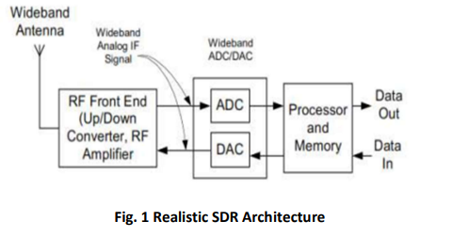

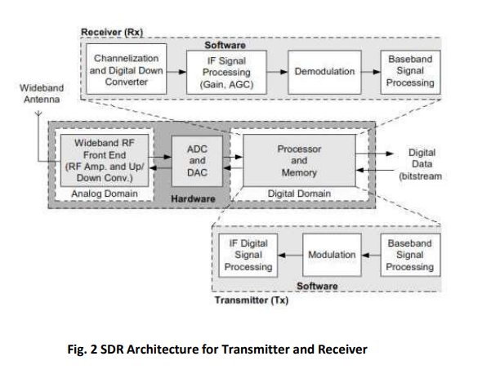

**Part 1 Block Diagram**

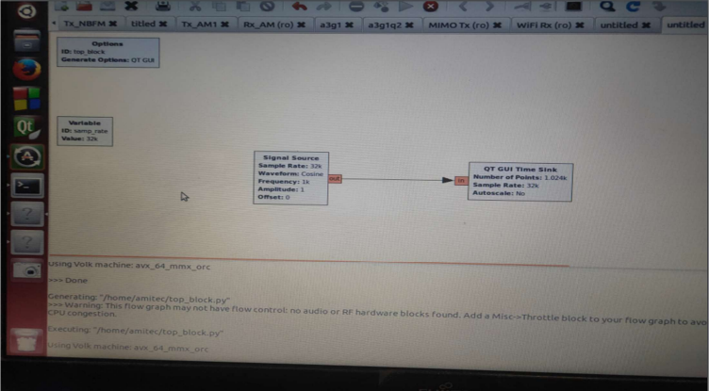

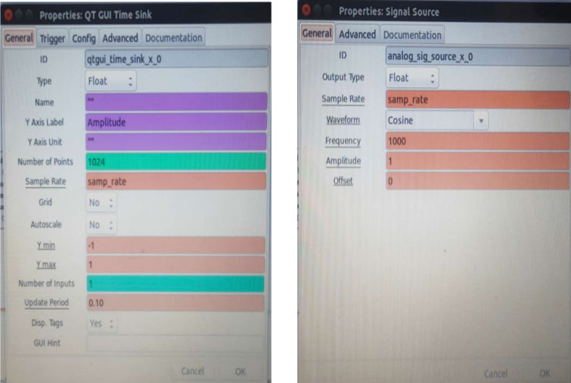

Properties QT GUI Time Sink Properties Signal Source

**Output 1**

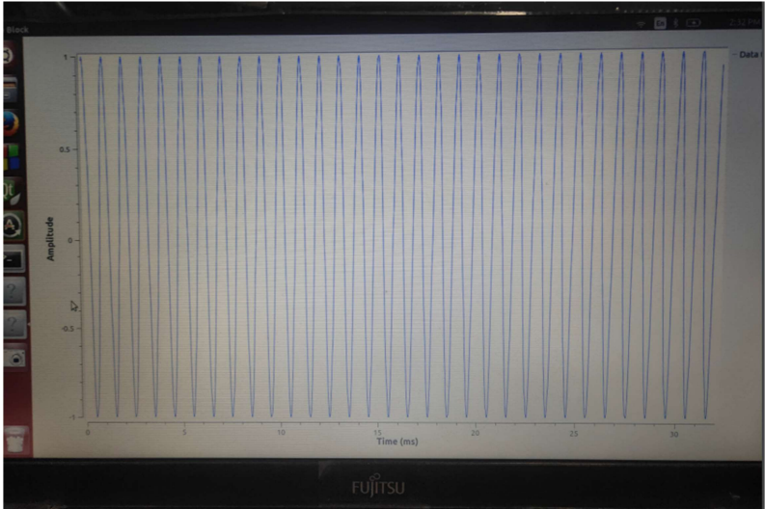

**Part 2 Block Diagram**

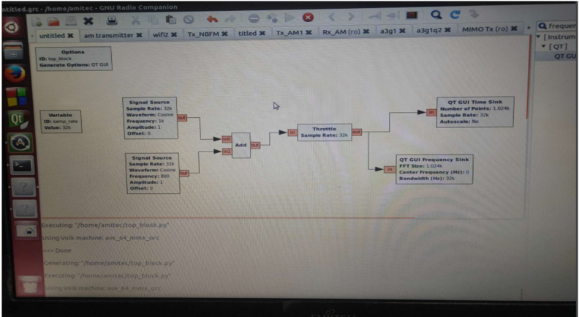

**Output 2**

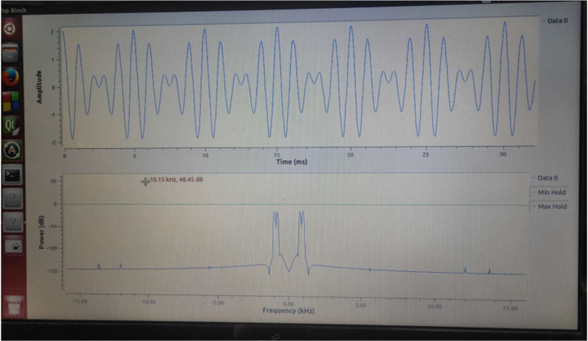

**Part 3 Block Diagram**

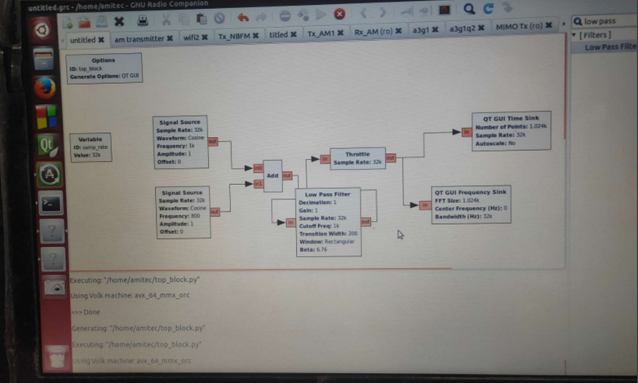

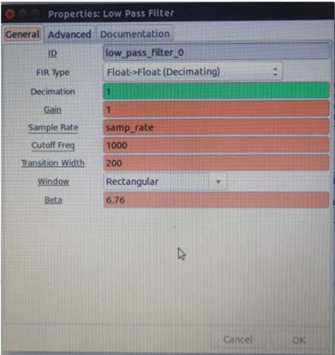

Properties of Low Pass Filter

**Output 3**

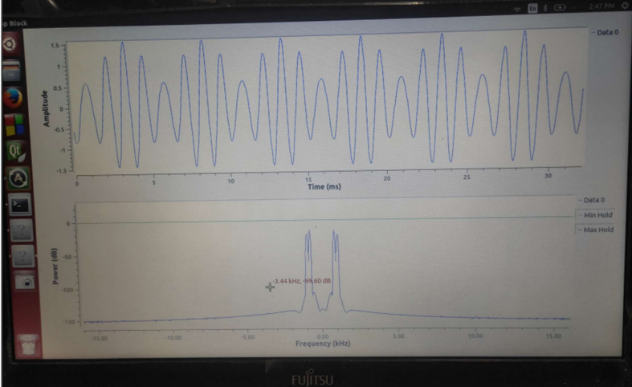

**Conclusion**

The basic understanding of SDR and GRC graphic tool was developed and the use of different block in different categories was understood. In this way, different functions can be generated using blocks from different categories.

**U19EC046 | WMC | LAB 12**

##### Objective

##### To Study about Mobile Phone Trainer Kit.

**Apparatus Required**

TechBook Scientech 2139

##### Technical Specification :

**Cellular System :** EGSM/GSM 900.

**Rx Frequency Band :** EGSM 925 960 MHz

**:** GSM 900 935 960 MHz

**Tx Frequency Band :** EGSM 880 890 MHz

**:** GSM 900 890 915 MHZ

**Output power :** +5... +33dBm/3.2 mW 2 W

**Channel spacing :** 200 KHz

**-Antenna -- :** Loop type, 50 ohms

**Display :** 84 x 48 pixels

**:** Antenna, Keypad, SIM, Charging

**On board sections** Circuit, Clock, User interface: Buzzer, Vibrator, LEDs.

##### No. of Test points : 41

**No. of Switched fault :** 25

**:** Screen saver, Ring tones, Logos,

##### Features that can be set

SMS etc.

**Power supply :** 220V f 10%, 50 Hz

**Power consumption :** 3.6 Watts (Approx.)

**Fuse :** 1.5 amps

**Dimension (mm) :** W 450 x H 113 x D 280.

**Weight :** 2.6 Kg (Approx.)

**An overview of GSM network:**

###### GSM network:

The GSM Network comprises three parts, Mobile Station (MS) which is similar to a cordless phone with extra features, the Base Transceiver Station (BTS) that controls the connection with the Mobile Station, the Base Station Controller (BSC) that controls multiply Base Transceiver Station's and then the rest of the network covered further below.

###### Mobile Station (MS):

A Digital Mobile Phone and a SIM card make up the Mobile Station. The SIM (Subscriber Identity Module) is a card that first into your handset. The SIM microprocessor is based on a silicon chip which is designed to tolerate temperatures between -25°C and +70°C, and will also withstand up to 85% humidity. However silicon is fragile and therefore, if the card is tampered with, physically or electronically, the card will be rendered useless. The SIM contains all of your identification details, such as your IMSI (International Mobile Subscriber Identity).This is a numeric string, where the first 3 digits represent the country where the SIM is from, the next represent the operator in that specific country. The other digits represent the subscriber's identity in his home-network), phone memories, billing Information, SMS text messages, pin numbers and international roaming information.

An IMEI (International Mobile Equipment Identity) card is the serial number of the GSM phone. The SIM card contains a IMSI (International Mobile Subscriber Identity) number that identifies the user to the network along with other user and security information.

###### Base Transceiver Station (BTS):

The Base Transceiver Station consists of a radio transceiver with antenna that covers a single cell. It handles the communications with the MS via radio interface. BTS are all connected together to allow you to move from one cell to another. The antenna can take on various forms.

###### Base Station Controller (BSC) :

The Base Station Controller manages multiple BTS's. It controls the allocation and release of radio channels and handovers between cells. A series of BTS's are connected. To each Base Station Controller, the BSC keeps an eye on each call and decides when to pass the call off to another BTS and to which one.

**The Rest of the Network:**

Several BTC's are controlled by the Mobile service Switching Center (MSC), the MSC works with four databases (HLR, VLR, EIR and the AUC) and together they manage the communications between Mobile Station user and the other network types. Each of the databases has a separate job.

###### Mobile Switching Center (MSC):

The Mobile Switching Center is the interface between the base station system and the switching subsystem of the mobile phone network. Furthermore, the MSC is also the interface between the cellular network and the PSTN. The MSC generates all billing records and ensures that all usage is directed to the appropriate account. The MSC has a relatively complex task, as unlike a conventional telephone exchange, when GSM subscribers make calls they could be anywhere within the network. The MSC must ensure that calls are routed through to those subscribers, wherever they are and wherever they move to throughout the duration of each cell. This situation becomes even more complex when two mobile subscribers wish to contact each other from two distant locations.

In order to simplify the subscriber management function, a specific service area is allocated to each MSC. The MSC has to control the switching of tariff to and from the subscribers within its service area which involves the co-ordination of all radio resources and the inter cell hand-off activities.

###### Home Location Register (HLR) :

The HLR is the central data base for all the subscribers which contain detaiIs on the identity of each subscriber, the services to which they have access and the locations where the subscriber was last registered. Once the Mobile Station's MSISDN has been used to identify the IMSI, the HLR verifies the subscription records to ensure that the call can be delivered to the last known location of the Mobile Station.

###### Visitor's Location Register (VLR):

The VLR is a database that is linked to an MSC and temporarily stares information about each Mobile Station within the area served by that MSC.

###### Equipment Identity Register (EIR):

The EIR ensures that all Mobile Equipment's, are valid and authorized to function on the PLMN.

###### Authentication Center (AUC):

The authentication center is used to validate the SIM Card being used by the Mobile Station. Secret information that is held in the AUC and which is also contained within the SIM Card is used to perform a complex mathematical calculation. Authentication occurs if the results of these two calculations agree.

###### SMSC (SMS Center or Service Center):

The SMSC handled all the SMS messages that are sent. The messages are sent on a data channel so you can receive them while on a call.

###### GMSC (Gateway MSC):

It is a gateway switch where the call is directed when setting up a call to a GSM user. The GMSC looks for the subscriber by interrogating the right HLR which then interrogates the VLR and routes the incoming call towards the MSC where the subscriber can be reached.

#### Outstanding Features:

###### Quality:

With digital, sound quality is sharp and clear. Background sounds and static are vastly reduced and crossed-line conversations are also eliminated. In comparison with analog there are also far fewer dropouts, and overall the quality is more like that of a fixed telephone.

###### Security:

Unlike analog, everything you say and send within the digital network is safe and secure. Some features are user authentication that prohibits unauthorized access, encryption key distribution that guarantees the privacy of the call and caller Identification restrictions that can prevent the delivery & identify calling-user's number to the receiver.

###### Convenience:

With digital, better technology means better battery life. You get up to twice as much talk time from each battery charge, compared with analogue. In addition the digital service allows more calls to be handled at any one time, therefore reducing congestion in areas of dense population and high usage.

###### Roaming:

Roaming is one more feature of GSM technology. With digital, you are able to use your mobile phone, and number in other countries around the world that operate a GSM network.

#### Features:

1. Call Forwarding
2. All Calls
3. No Answer
4. Engaged
5. Unreachable
6. Call Barring
7. Outgoing - Bar certain outgoing calls (e.g. ISD)
8. Incoming - Bar certain incoming calls (Useful if in another country)
9. Global roaming - Visit any other country with GSM and a roaming agreement and use your phone.
10. SMS - Short Message Service - Allows you to send text messages to and from phones
11. Multi Party Calling - Talk to five other parties, as well as yourself at the same time
12. Call Holding - Place a call on Hold
13. Call Waiting - Notifies you of another call whilst on a call
14. Mobile Data Services - Allows handsets to communicate with computers
15. Mobile Fax Service - Allows handsets to send, retrieve and receive faxes
16. Calling Line Identity Service - This facility allows you to see the telephone number of the incoming caller on our handset before answering
17. Advice of Charge - Allows you to keep track of call costs
18. Cell Broadcast - Allows you to subscribe to local news channels
19. Mobile Terminating Fax - Another number you are. Issued with that receives faxes that you can then download to the nearest fax machine.
20. Upgrade and improvements to existing services
21. Majority of the upgrade concerns data transmission, including bearer services and packet switched data at 64 Kbits and above
22. SIM enhancements

#### GMSK Modulation:

GSM uses a digital modulation format called 0.3GMSK (Gaussian minimum shift keying). The 0.3 describes the bandwidth of the Gaussian filter with relation to the bit rate. The bandwidth of 0.3 was chosen as a compromise between spectral efficiency and inter symbol interference.

GMSK is a special type of digital FM modulation. 1's and. 0's are represented by shifting the RF carrier by plus or minus 67.-708. KHz. Modulation techniques which use two frequencies to represent one and zero` are denoted FSK (frequency shift keying). In the case of GSM the data rate of 270.833kbit/sec is chosen to be exactly four times the RF frequency shift. This has the effect of minimizing the modulation spectrum and improving channel efficiency. FSK modulation where the bit rates exactly four times the frequency shift is called MSK (minimum-shift keying). In GSM, the modulation spectrum is further reduced by applying a Gaussian pre-modulation filter. This slows down the rapid frequency transitions, which would otherwise spread energy into adjacent channels.

0.3GMSK is not phase modulation (i.e. information is not conveyed by absolute phase states, as in QPSK for example). It's the frequency shift or change of phase state which conveys information. GMSK can be visualized from an I/Q diagram. Without the Gaussian filter, if a constant stream of l's is being - transmitted, MSK will effectively stay 67.708 KHz above the carrier center frequency. If the carrier center frequency is taken as a stationary phase reference, the 67.708 KHz signal will cause ; steady increase in phase. The phases will role 360 degrees at a rate of 67,701 revolutions per second. In one bit period (1/270.833 KHz), the phase will get a quarter of the way round the I/Q diagram or 90 degrees. I's are seen as a phase increase of 91 degrees. Two l's causes a phase increase of

180 degrees, three l's 270 degrees and so on. 0's cause the same phase change in the opposite direction.

The exact phase trajectory is very tightly controlled. GSM use's digital filters and I/( or digital FM modulators to accurately generate the correct trajectory. The GSM specification allows no more than 5 degrees rms and 20 degrees peak deviation four the ideal trajectory.

GMSK, is a form of modulation used in a variety of digital radio communications systems. It has advantages of being able to carry digital modulation while still using the spectrum efficiently. One of the problems with other forms of phase shift keying is that the sidebands extend outwards from the main carrier and these can cause interference to other radio communications systems using nearby channels.

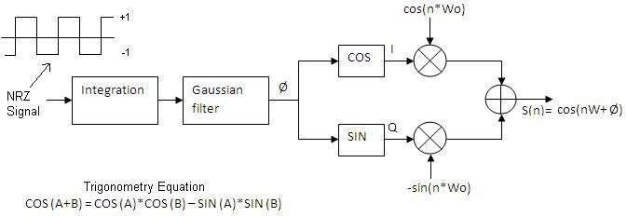

#### GETTING STARTED:

##### Fig. 1 GMSK Transmitter Block Diagram

1. Check the battery is received in proper condition.
2. Insert SIM card of any 900MHz service provides in the SIM assembly.
3. Now, insert the battery so that the battery contacts and assembly Terminal match.
4. Switch ON the trainer by pressing the power ON/OFF switch, located at the top right most corner.

Note: Whenever the switch is operated ON/OFF LED operates.

1. When/If the battery is low. Connect the mains cord and operate the Charging switch located at the top right most corner below the power switch.
2. Mode: This is an improved feature of ST2132. The mode has to be selected prior to switching ON the trainer.

DC Mode: In normal switch position, trainer operates with battery supplied & charging facility functions normally.

AC Mode :When switch pressed trainer operates on AC & mains cord is a must for the supply. The trainer automatically disconnects the battery

contacts when the mode is changed from DC to AC. So, physical presence of the battery in the battery assembly doesn't have any effect. The charging On/Off switch stops the functioning in this mode.

Note: Switch OFF the trainer before switching between the operating modes.

**Procedure:**

#### Task 1: To study the Tx IQ and Rx IQ signals.

1. Insert the SIM and power ON the trainer.
2. Make a Call to the trainer or from the trainer.
3. Keep the Call ON

Connect the probe of spectrum analyzer at Tp. 1 and observe the signal in the Tx band.

Now connect the probe to Tp. 2 observe the signal in the Rx band.

Connect two probe of CRO one at Tp. 3 and the other on Tp. 4 observe the Rx burst. A similar Rx burst can be observed by connecting probe Tp. 5 and Tp.6 respectively. Signal fig.2 shows a IQ Tx and Rx burst signal.

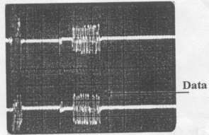

**Fig. 2 Burst Signal**

#### Task 2: To observe signal constellation of GMSK signal.

##### Procedure:

1. Make a Call to the trainer.
2. Receive the Call and Keep the Call ON
3. Connect two probe of CRO one at Tp. 3 and the other on Tp. 4 observe the Rx burst signal fig.3 shows a IQ Rx burst signal.

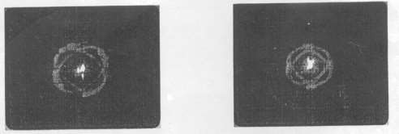

##### Fig 3. Constellation at Receiver end

**Procedure**

#### Task 3: GSM Data Rate and GMSK encoded signal

1. Make a call to the trainer.
2. Connect the probe of CRO at TP. 5 or TP 6.
3. Observe the signal As shown in fig.4 (a).
4. Expand the signal to see the eye pattern.
5. Expand the signal.
6. Observe the GMSK encoded signal

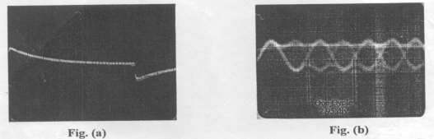

##### Fig. 4 Waveform observed during a call

**Conclusion:**

Using Mobile Phone Trainer Kit TechBook Scientech 2139, we studied and analyzed various signals and operations on DSO and also analyzed frequency spectrum of ongoing call on Frequency Analyzer.

**U19EC046 | WMC | Android Task**

**AIM**

To take two numbers from the user and perform multiplication

**Team members:**

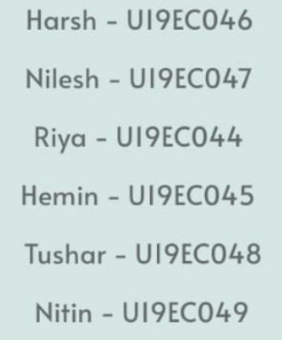

**ALGORITHM**

1. Import necessary libraries.
2. Create an event click listener on “calculate” button.
3. On click get the expression from the expression field.
4. We are using mxParser library to evaluate the math expression string. Pass on this expression.
5. Create a new instance of expression class with expression string as parameter.
6. Call calculate method on this instance to get the result.
7. Convert this result to string and update the textView.

**CODE**

1. MainActivity.java

|  |
| --- |
| **package com.example.multiplier;**  **import androidx.appcompat.app.AppCompatActivity;**  **import android.os.Bundle;**  **import android.view.View;**  **import android.widget.Button;**  **import android.widget.ImageButton;**  **import android.widget.TextView;**  **import org.mariuszgromada.math.mxparser.Expression;**  **public class MainActivity extends AppCompatActivity {**  **@Override**  **protected void onCreate(Bundle savedInstanceState) {**  **super.onCreate(savedInstanceState);**  **setContentView(R.layout.activity_main);**  **Button clickButton = (Button) findViewById(R.id.submitBtn);**  **ImageButton infoButton = (ImageButton) findViewById(R.id.infoButton);**  **ImageButton closeButton = (ImageButton) findViewById(R.id.closeButton);**  **View overlayView = (View) findViewById(R.id.overlayContainer);**  **TextView expressionField = (TextView) findViewById(R.id.expressionInput);**  **clickButton.setOnClickListener(v -> {**  **String expression = expressionField.getText().toString();**  **System.out.println(expression);**  **Expression e = new Expression(expression);**  **Double result = (Double) e.calculate();**  **String resultStr = result.toString();**  **expressionField.setText(resultStr=="NaN"?"Invalid expression":resultStr);**  **});**  **infoButton.setOnClickListener(v->{**  **overlayView.setVisibility(View.VISIBLE);**  **});**  **closeButton.setOnClickListener(v->{**  **overlayView.setVisibility(View.GONE);**  **});**  **}**  **}** |

**OUTPUT**

|  |  |  |
| --- | --- | --- |
|  |  |  |